Docker <https://www.youtube.com/watch?v=3c-iBn73dDE>

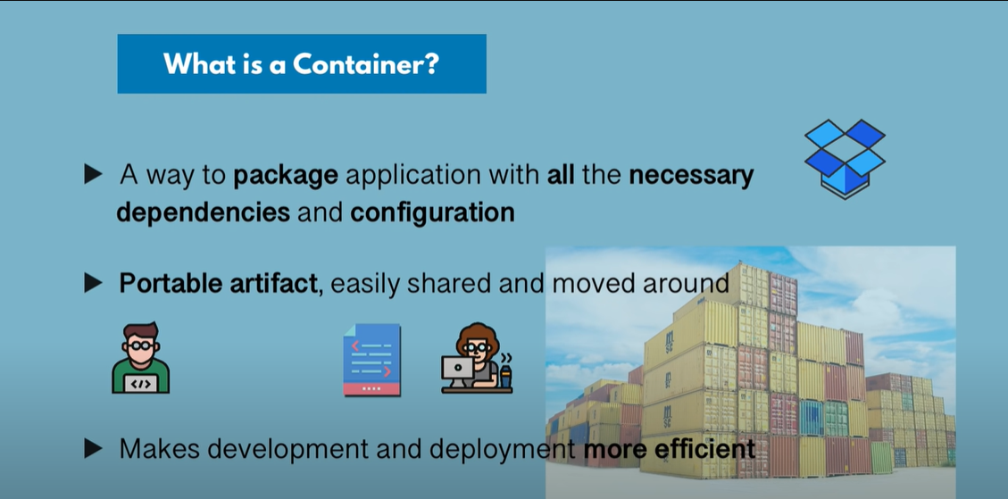

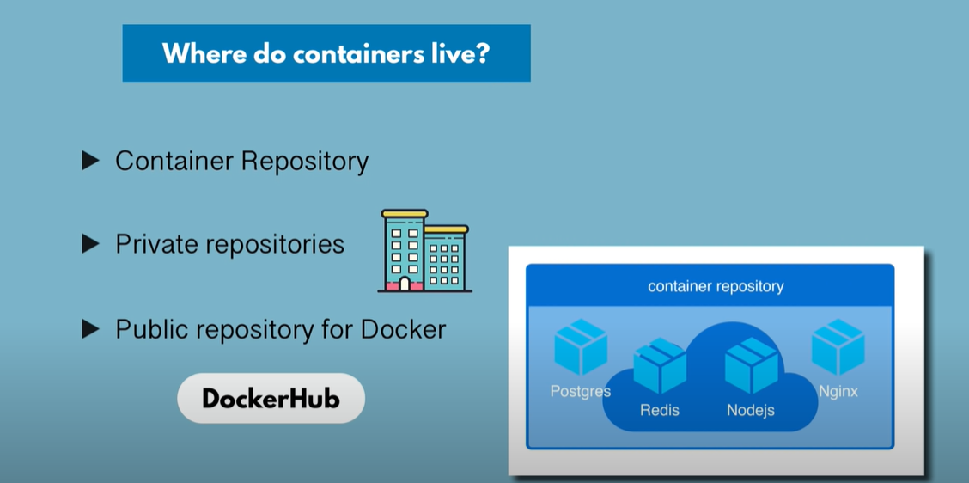

Docker images available in docker hub repository which is public repository

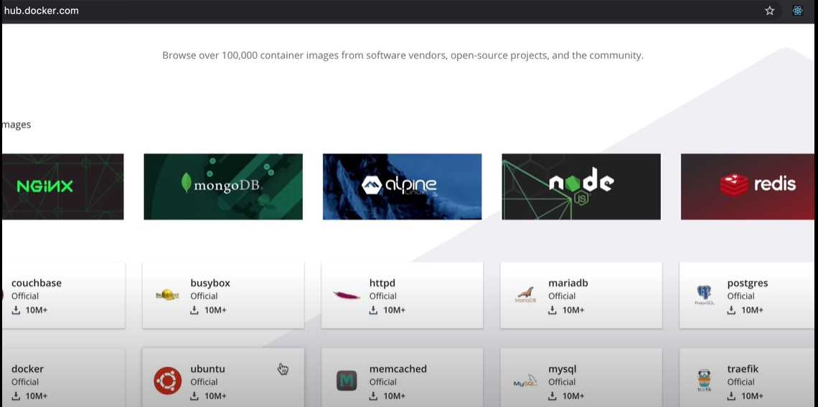

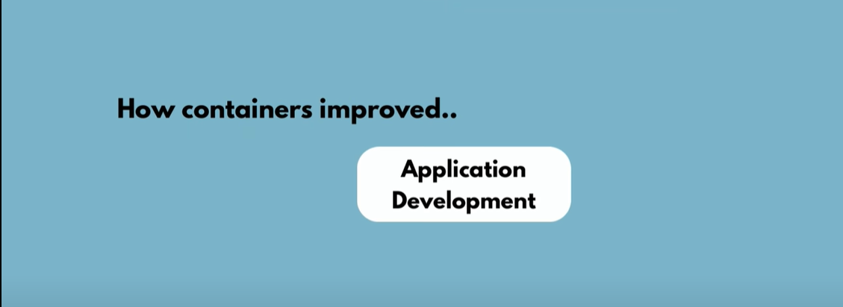

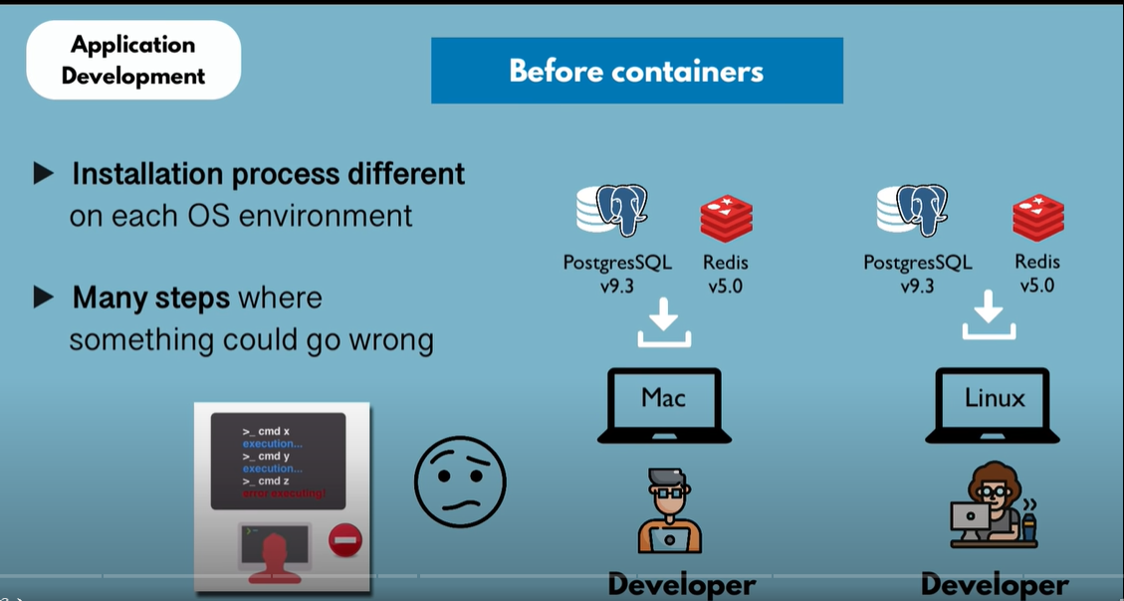

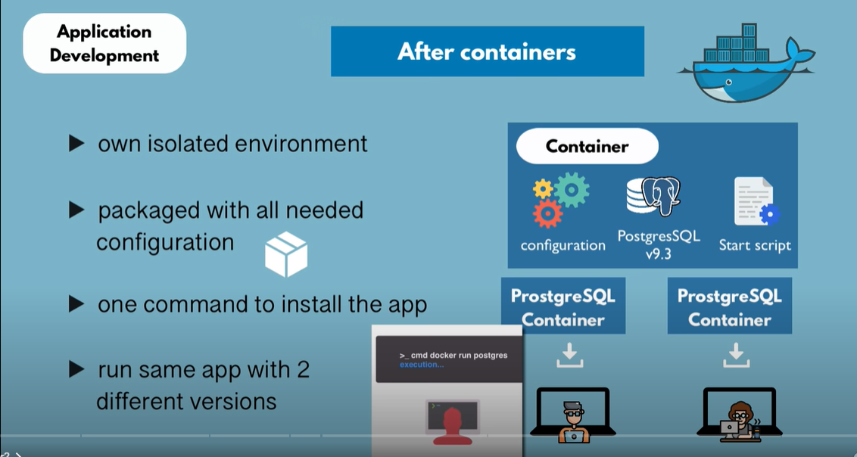

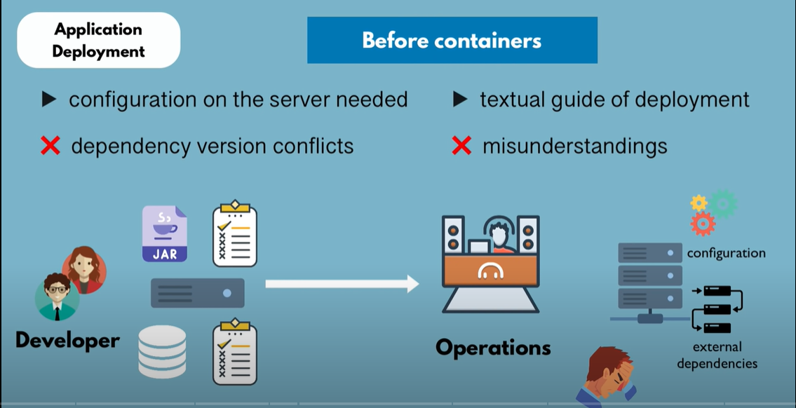

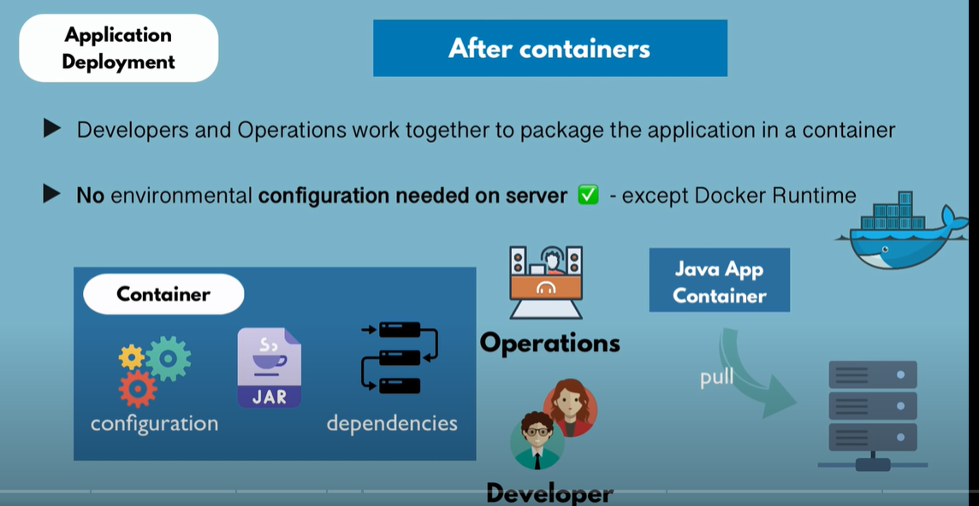

A container consists of Layers of Images.

First is the **Base Image** and then **Application images on top of it**

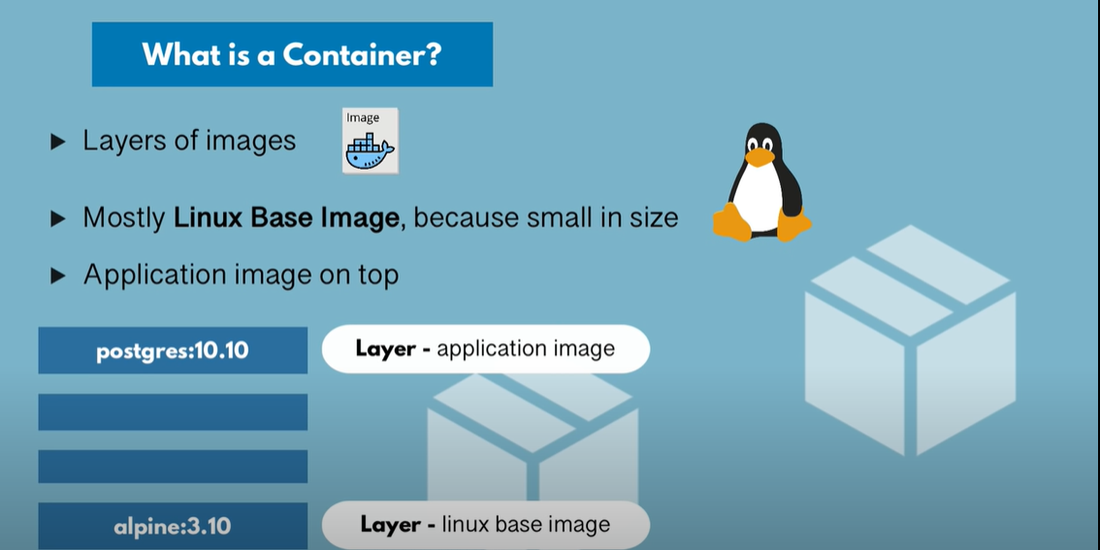

Once we run any image for first time…multiple layers (Linux base image layer, application layer etc) are downloaded as shown below. And as part of first time run, the download will take more time as it downloads all layers.

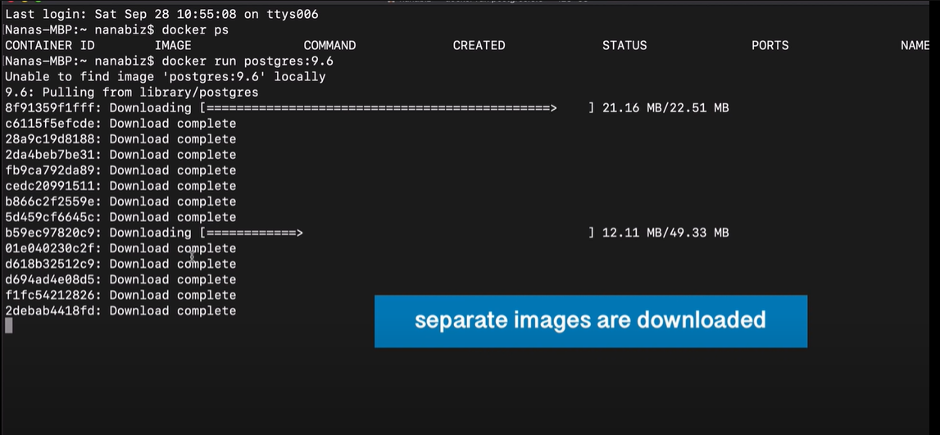

Advantage of having layers: if newer version of Postgres is required. Then only the app image with newer version is downloaded. Other layers need not be downloaded again. And this time download time will be less as only app image id downloaded.

In below screenshot, **Already exists** means those images are already present and only newer version of app is downloaded

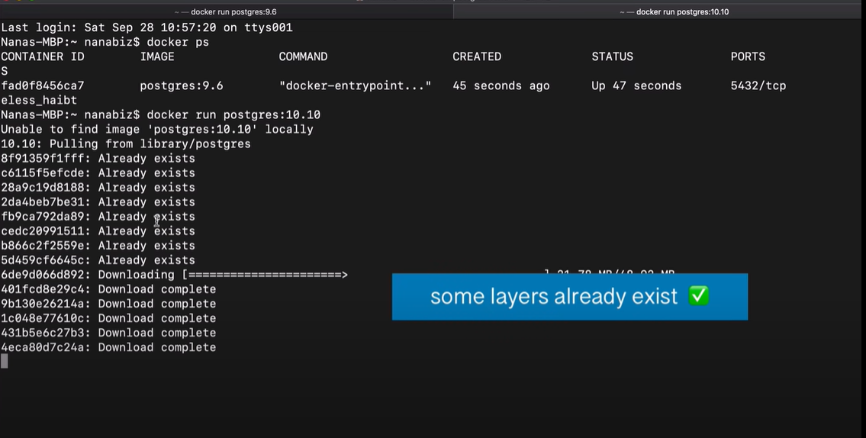

Running version of an image is called a container

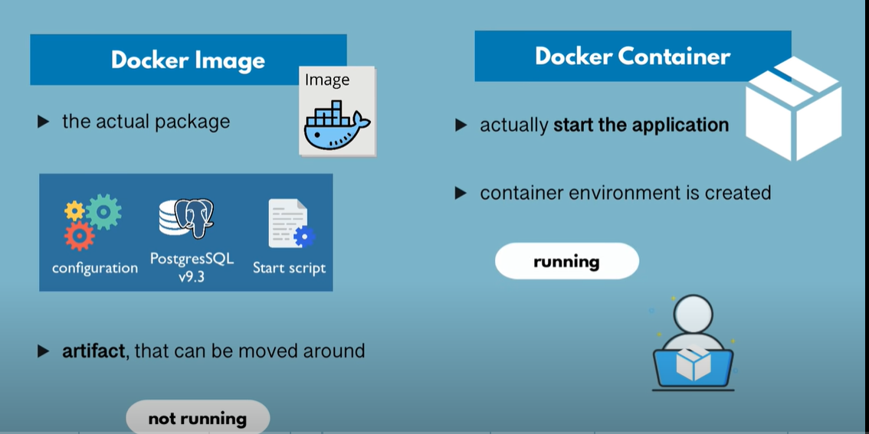

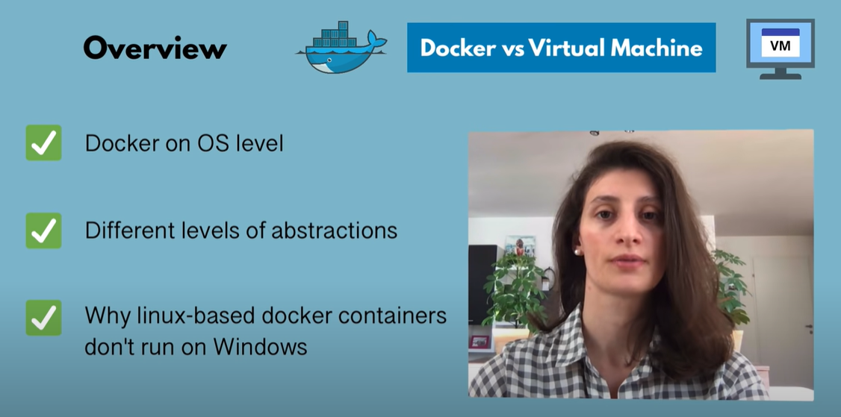

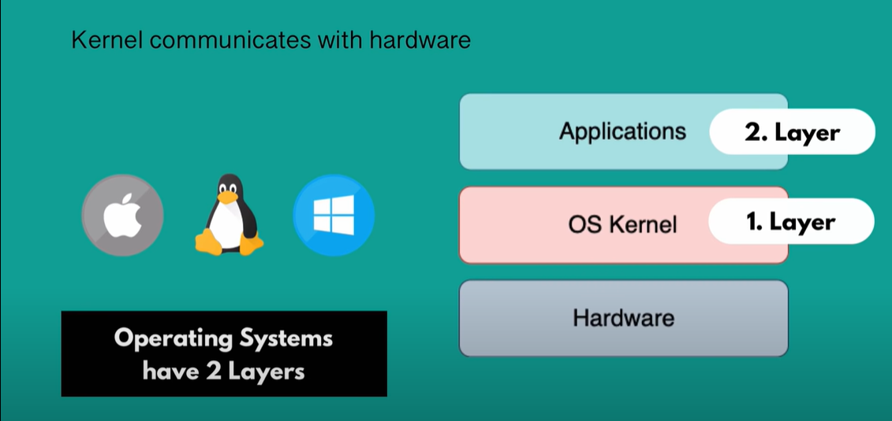

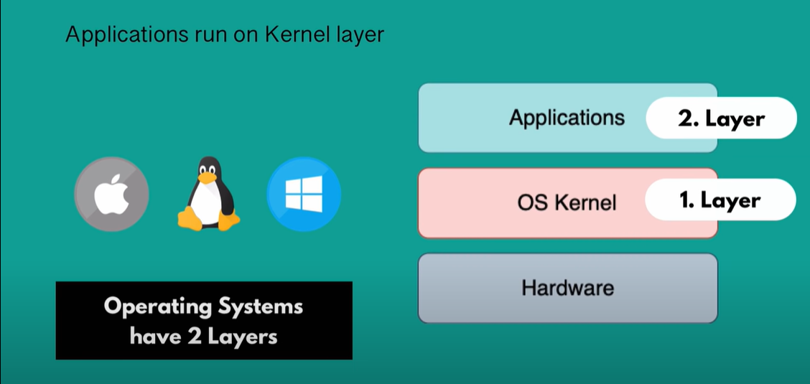

Docker virtualizes only the Application layer, while VM virtualizes the application and Kernel

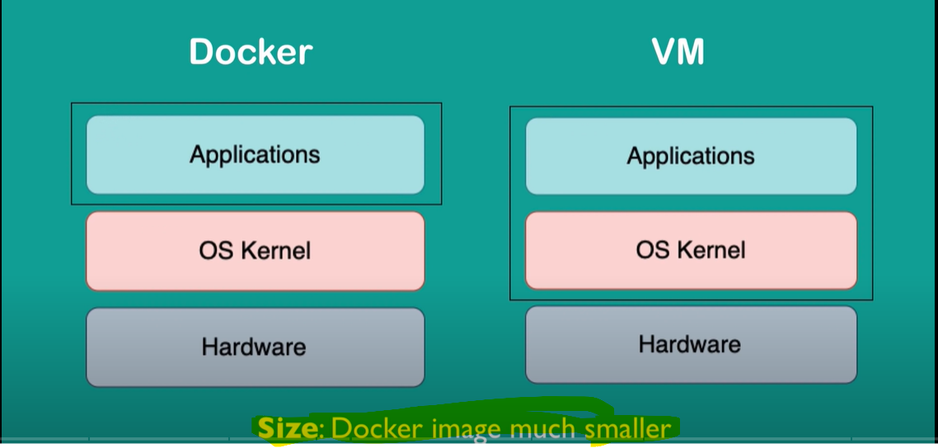

Dockers are Speed in terms of start and run

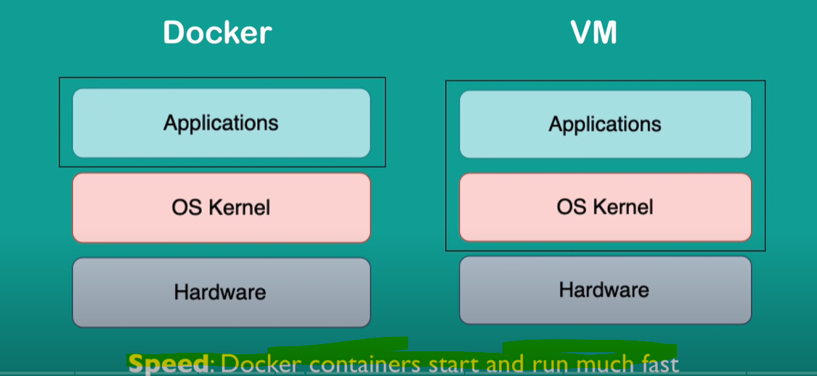

VM of any OS can run on any OS host, but the same is not true for Docker.

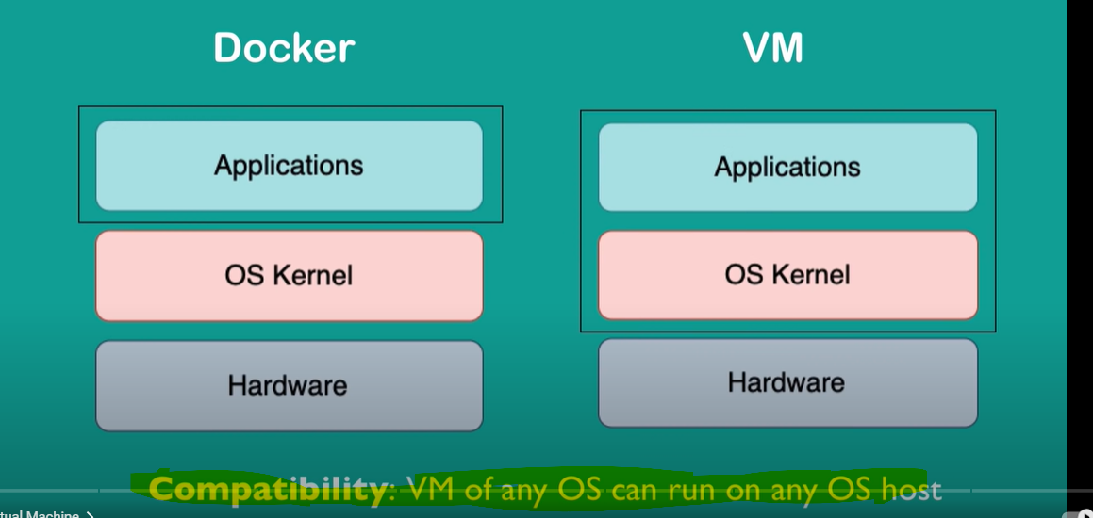

Below image shows a Linux based docker image is not compatible with windows kernel. This is applicable till Windows 10.

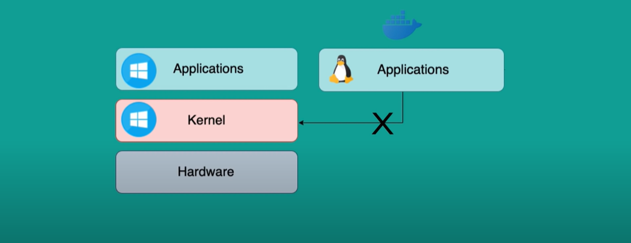

Workaround: Docker toolbox will help to run any images on any kernels.

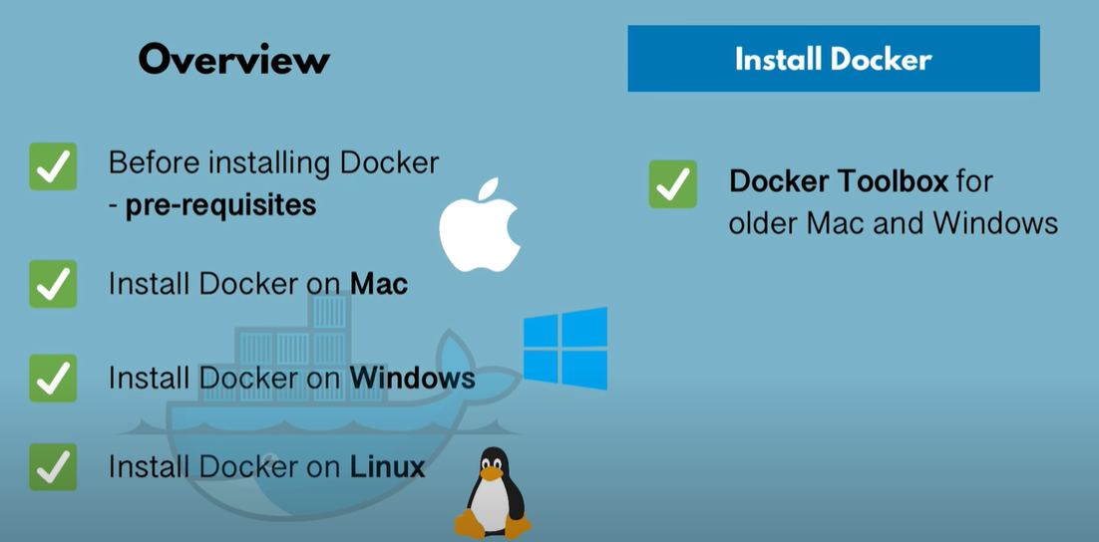

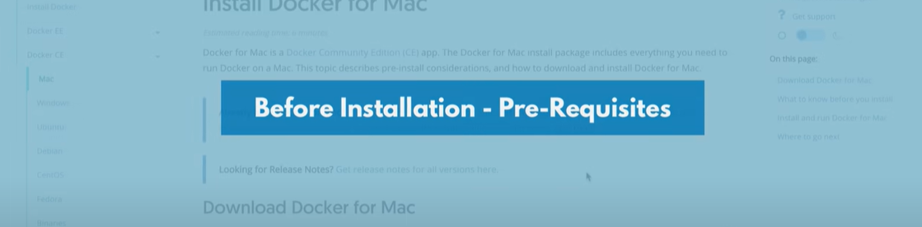



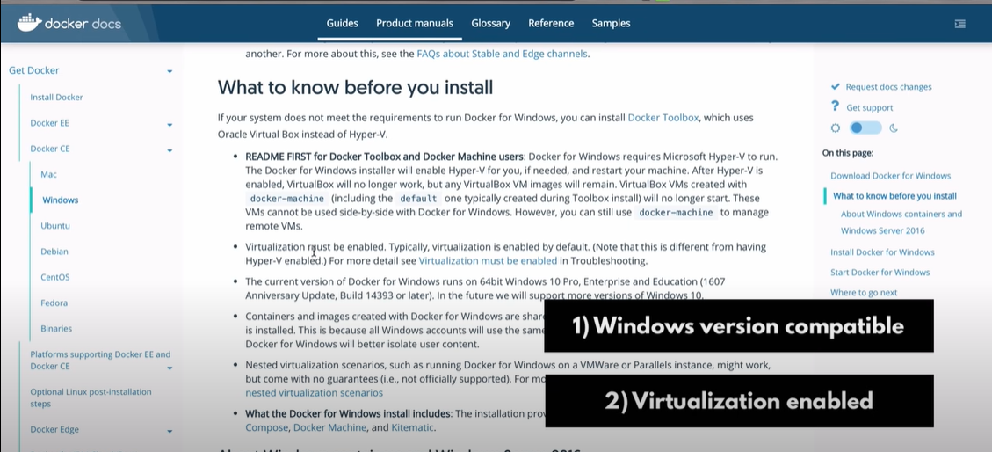

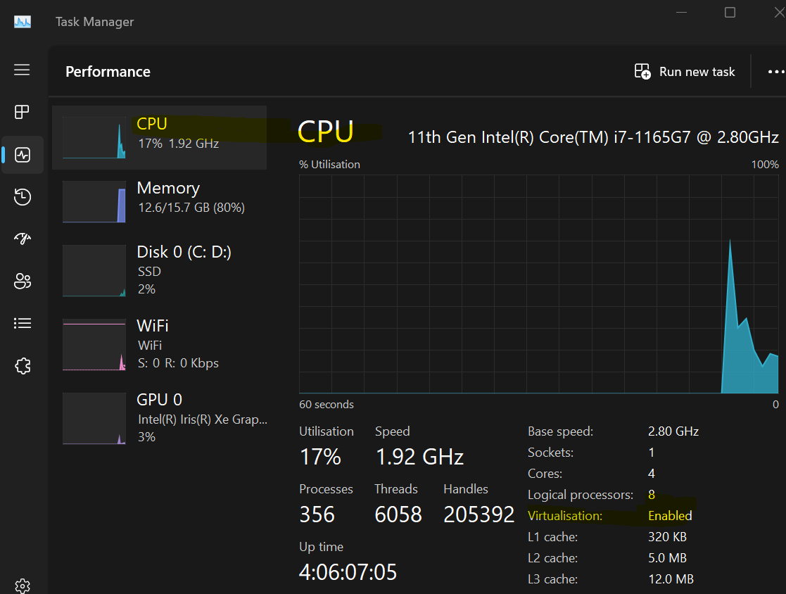



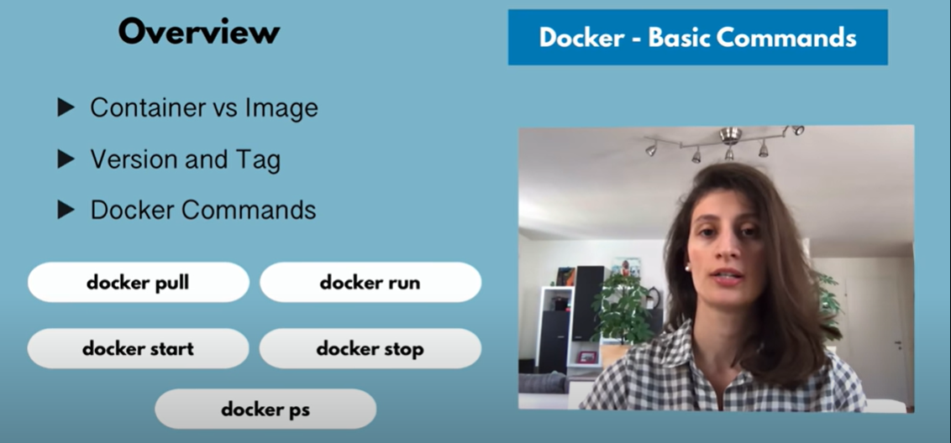

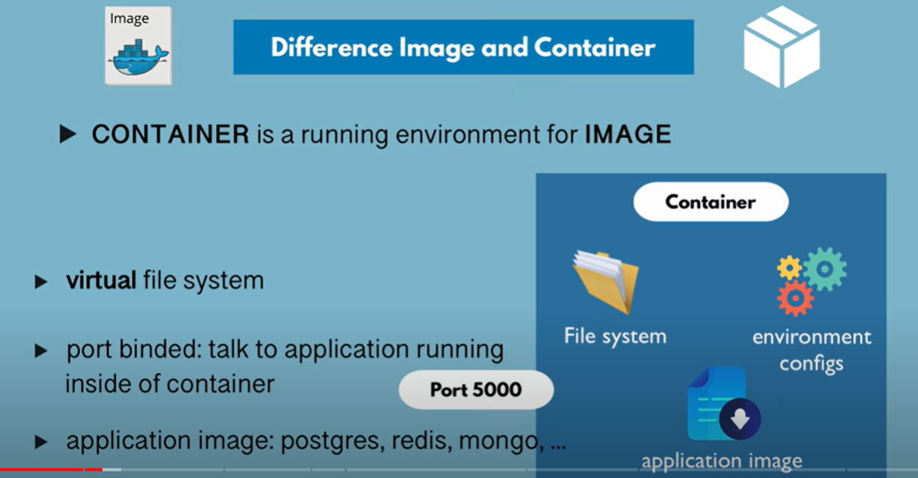

Docker run <app_name> : to run an image

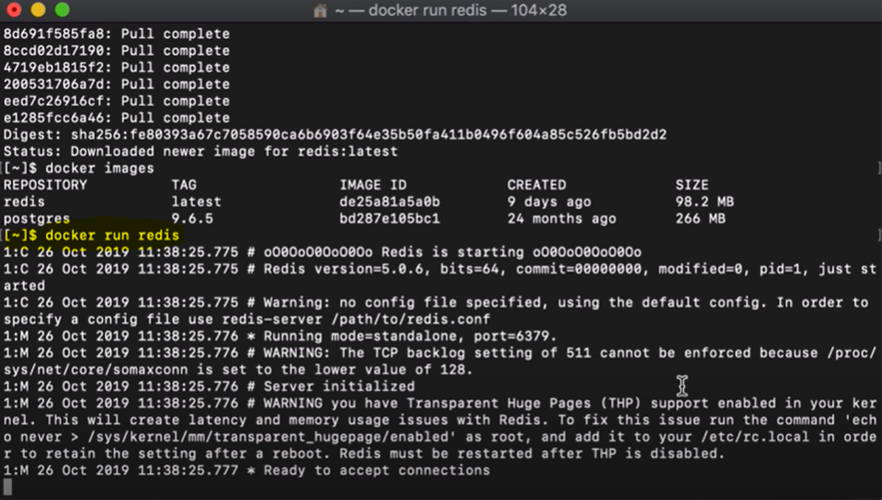

Docker ps : to list running containers

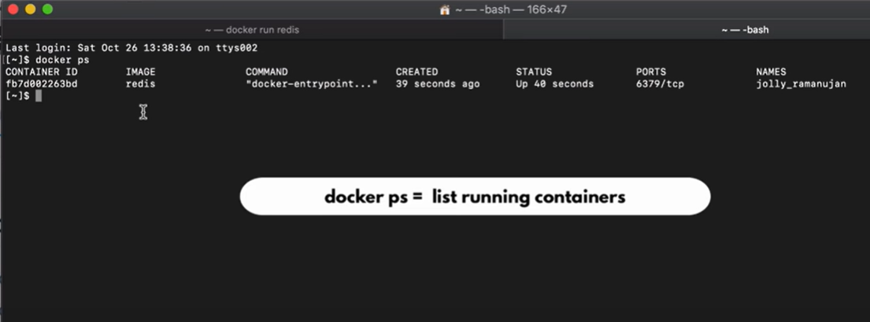

Docker run -d <app-name> : to run app in detached mode

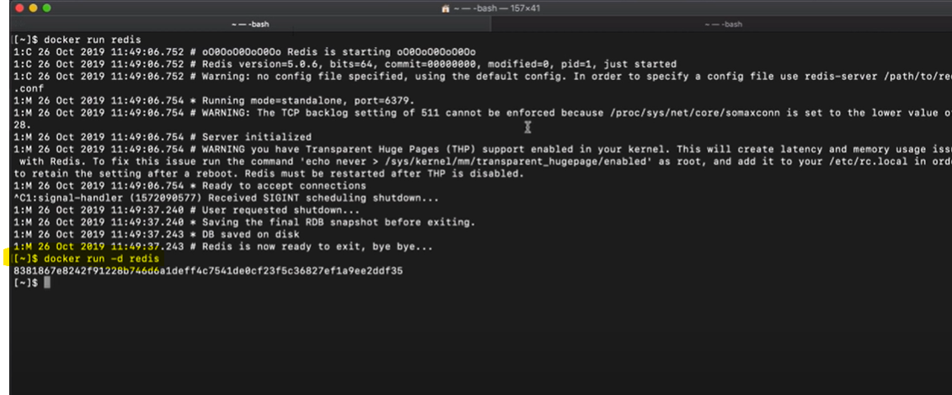

Docker stop <container_id> : to stop the app

Docker start <container_id> : to start the app

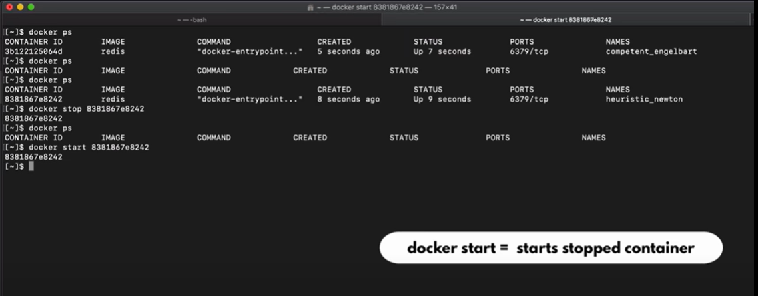

Docker ps -a : lists running and stopped containers

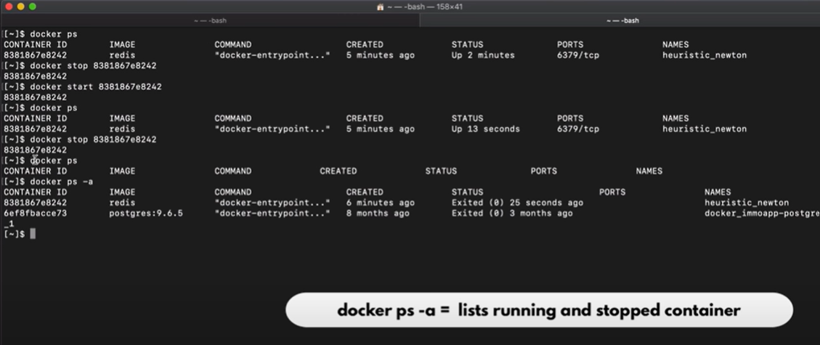

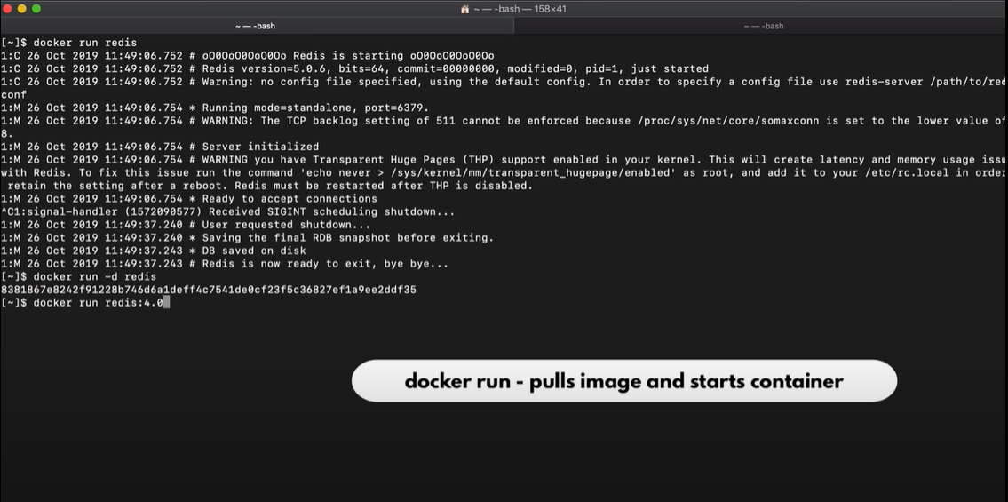

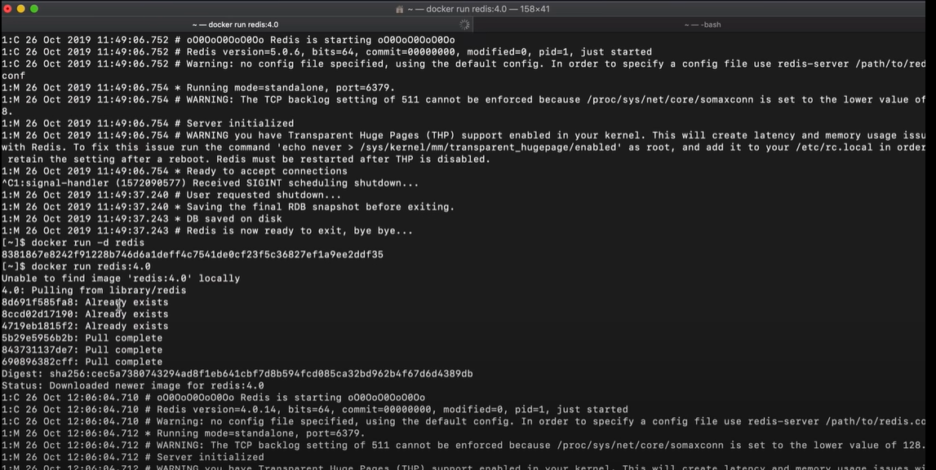

Below snapshot shows 2 different versions of redis running on **SAME port !! Which is still Ok…because containers port can be same where as host port(laptop port) should not be same. In this case we need to bind the container port with the host port.**

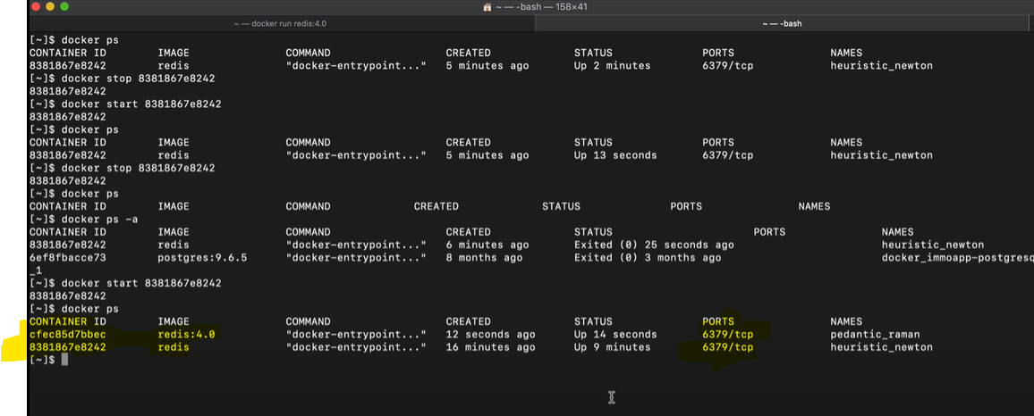

Command to bind host port to container port

docker run -p<hostport>:<container port> <app name>

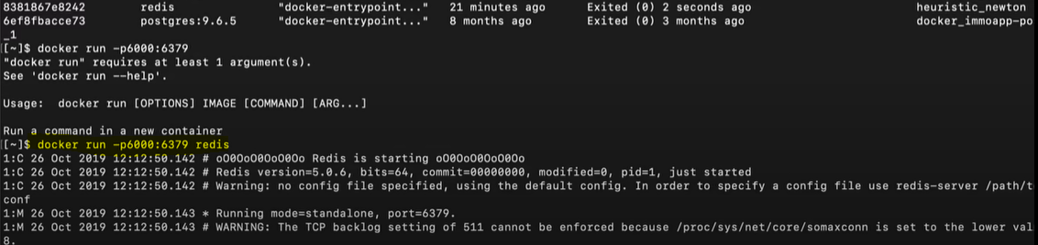

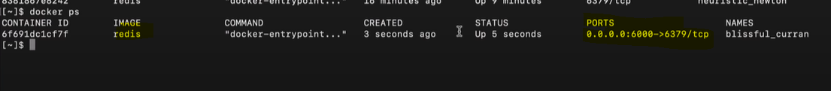

Below snapshots shows two different versions of redis running and bind to 2 different ports of host port.



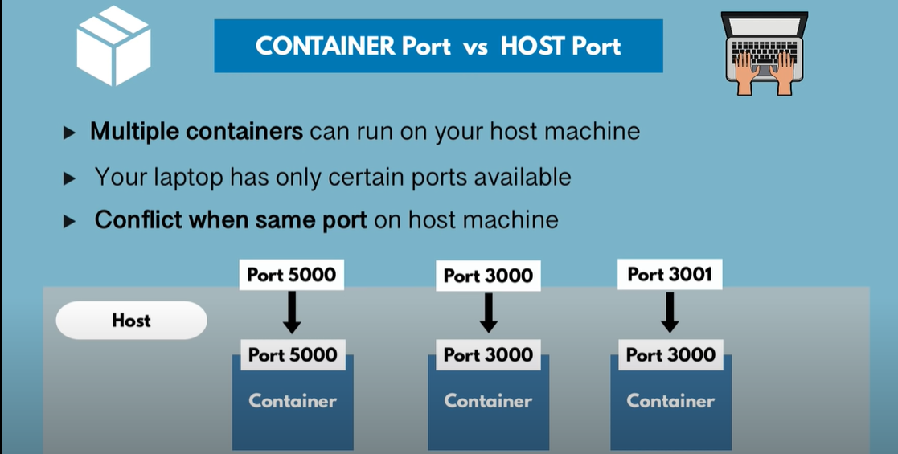

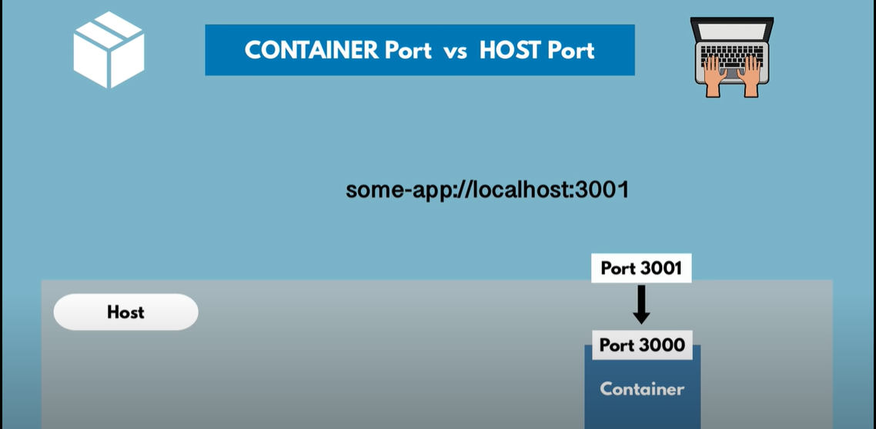

Docker debug

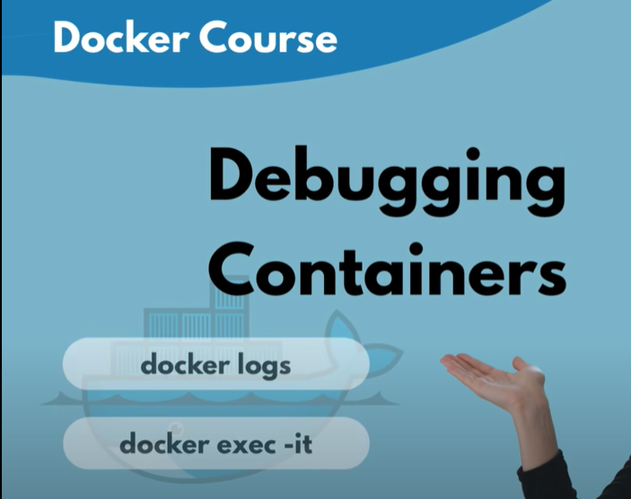

To check logs of a specific container

docker logs <container_id>

docker logs <container_name>

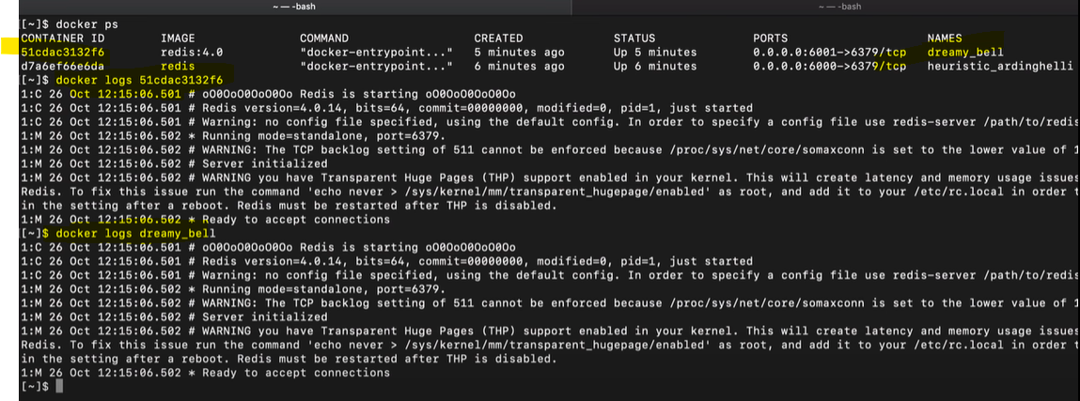

Command to create and run an application on specific port with custom name

docker run -d -p76001:6379 --name <custom_container_name> <app_name>

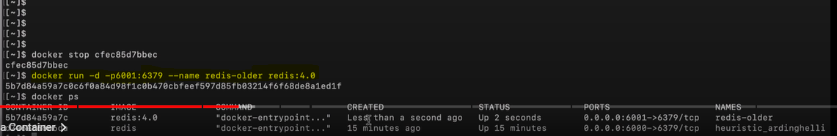

Command to open a container in a interactive terminal(it), to navigate through its folders etc

docker exec -it <container_name> /bin/bash

OR

docker exec -it <container_id> /bin/bash

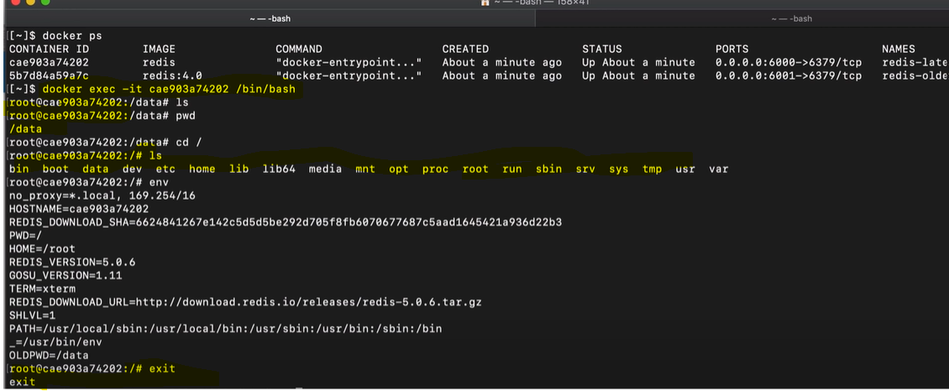



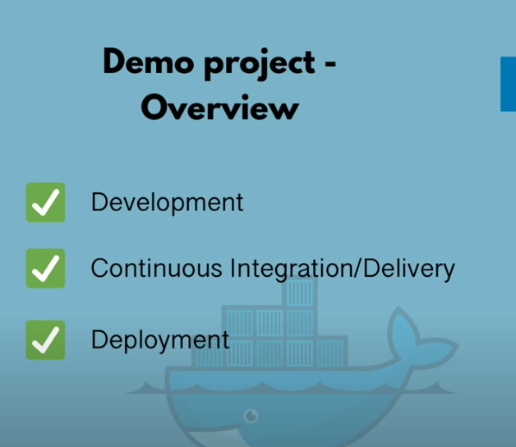

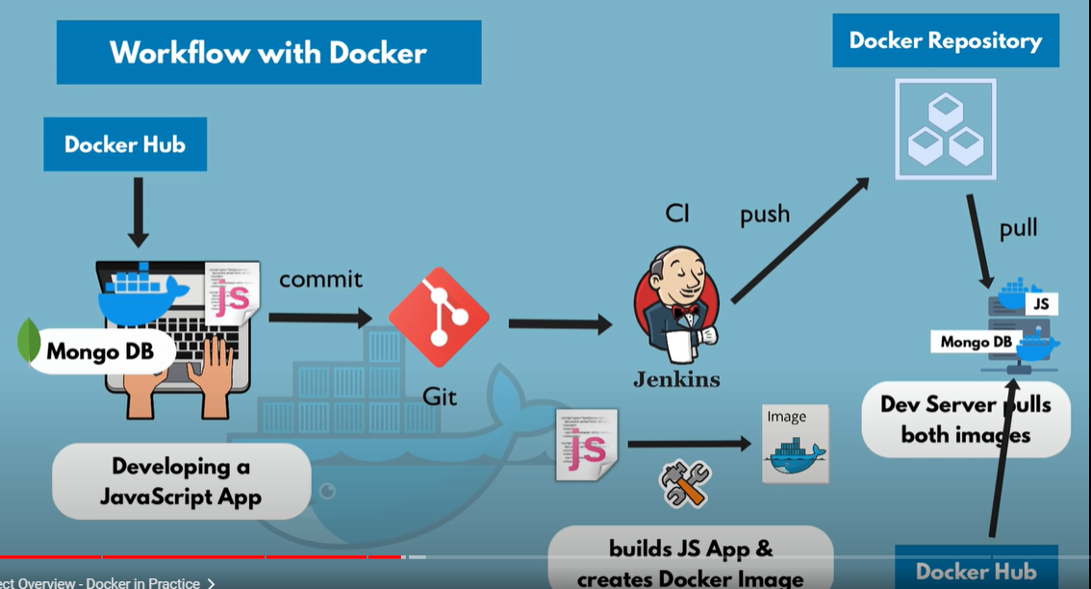

1. Develop Java script app in your local laptop.
2. This app used MongoDB. So instead of downloading MongoDB in local, we take the Mongo image from Docker Hub
3. Then push the changes to Git and Jenkins will trigger build.
4. Jenkins builds Java script app and creates Docker Image and pushes it to our organization's Docker Repository
5. Next the development server pulls the JavScript image from organisations Docker repository and MongoDB image from Docker hub.
6. Next if a tester logs into dev server, he should be able to test the application without any issues

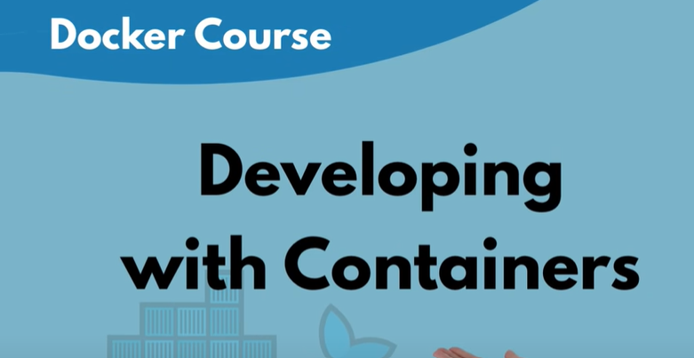

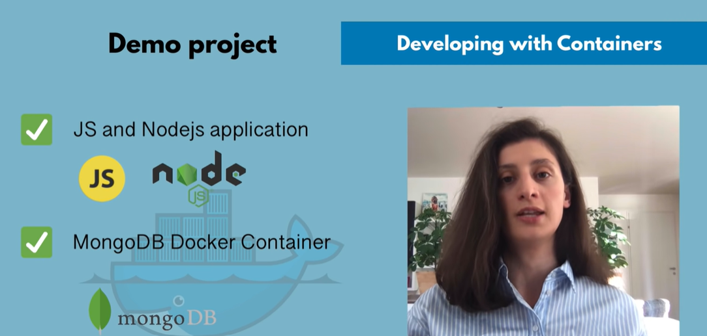

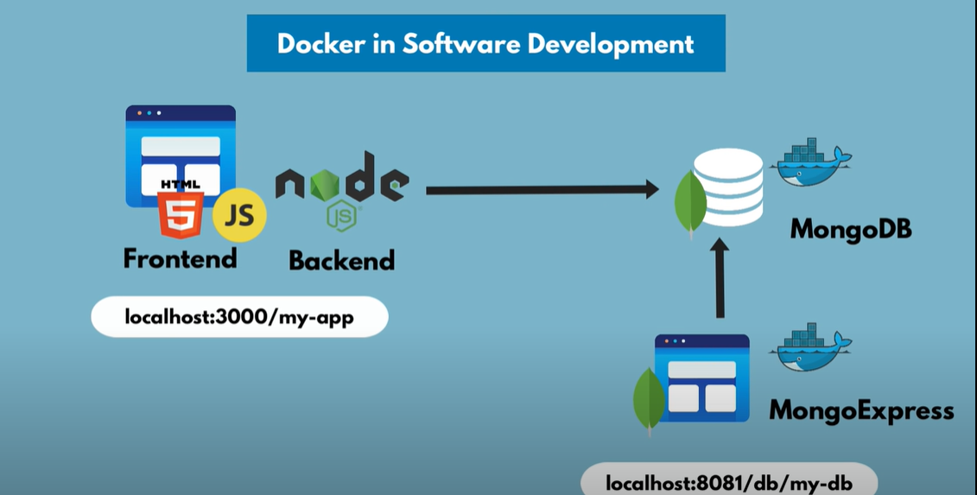

Sample JS and nodejs application running on port 3000 which allows to edit and save profile details

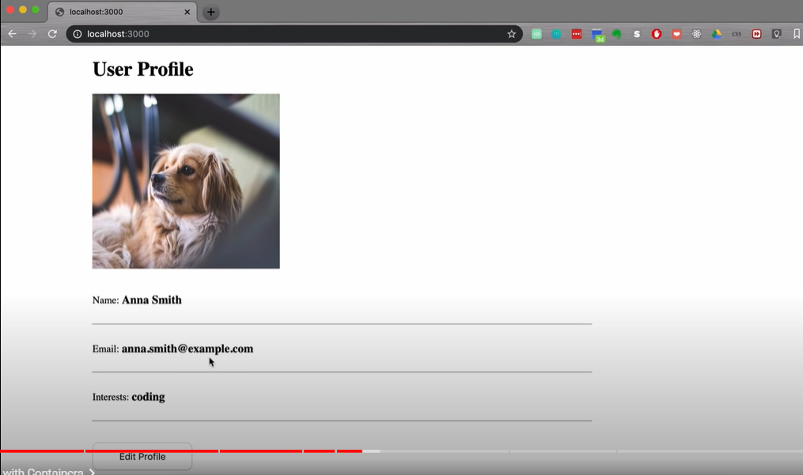

MongoExpresss is used to access MongoDB via UI

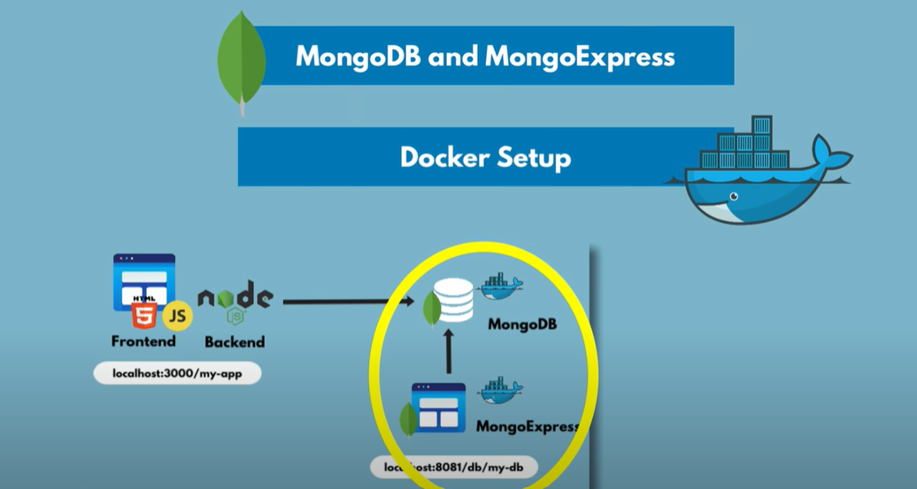

Docker network used to connect MongoDB and MongoExpress.

When 2 containers(MongDB and MongoExpress) are running in same docker network inside a particular host(laptop), they can talk to each other **JUST** via container names.

While the app running outside docker network (node js app), need to talk to mongoDB via localhost:<port>

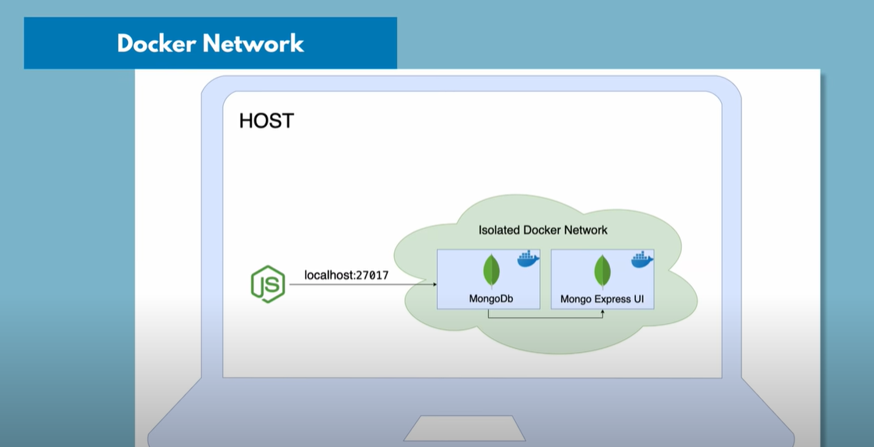

And once when we package our application , the node js also will come inside docker network as shown below. And the browser which is outside the docker container and used to access the node js app will connect to nodejs via localhost:<port>.

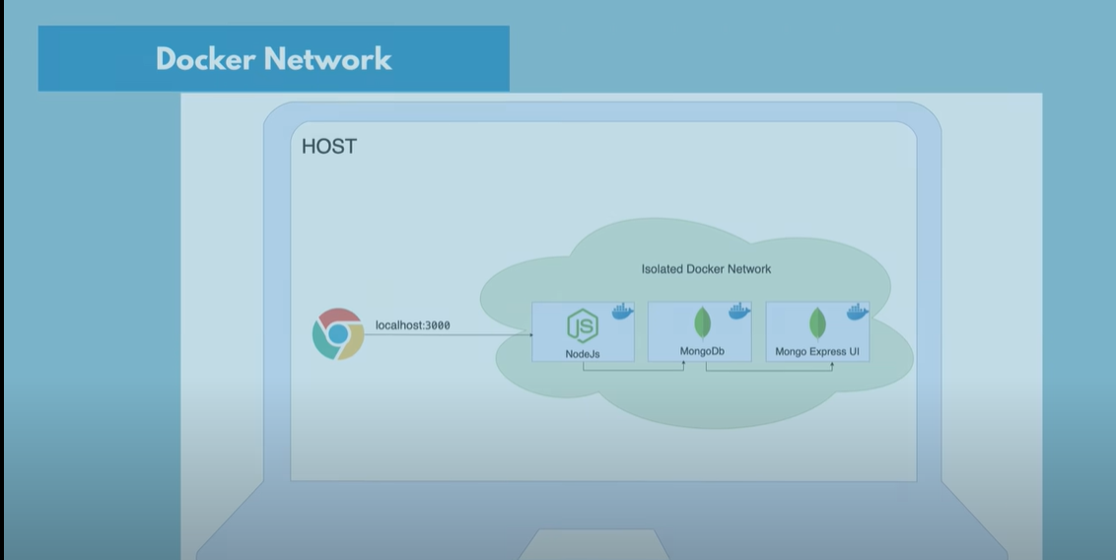

Default networks provided by docker

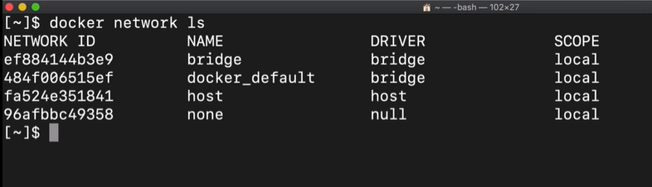

Command to create custom network

docker network create <network_name>

Here we will create a separate network for mongoDB and mongoExpress

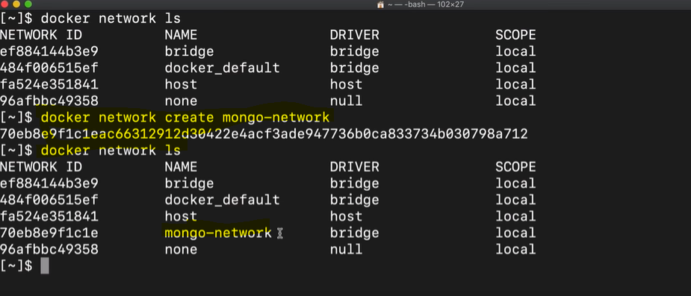

Command to run mongo container using port(p-) , environmental variables(-e) i.e username and pwd , custom container name and the network in which it should run in detached mode(-d)

Docker run -p <hostport>:<container_port> -d -e <mongo_username> -e <mongo_pwd> --name <custom_container_name> --net <network name> <application name>

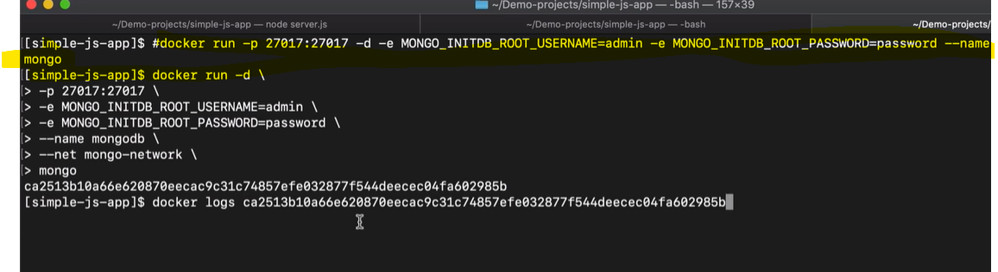

Mongo started on port 27017

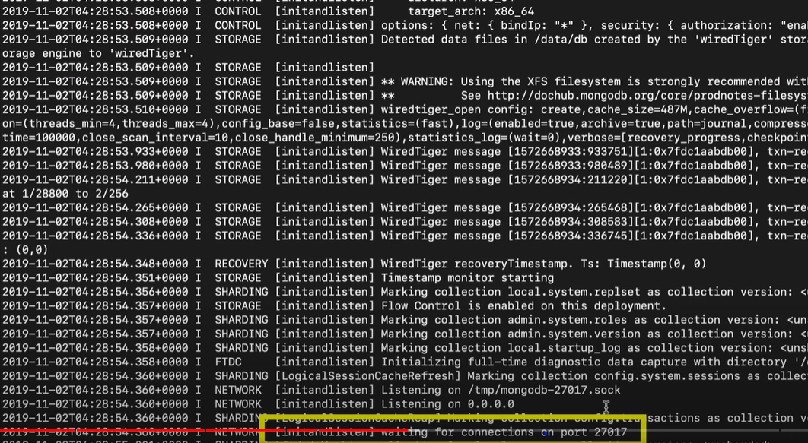

Below are some of the properties required to run MongoExpress and connect to MongoDB on startup

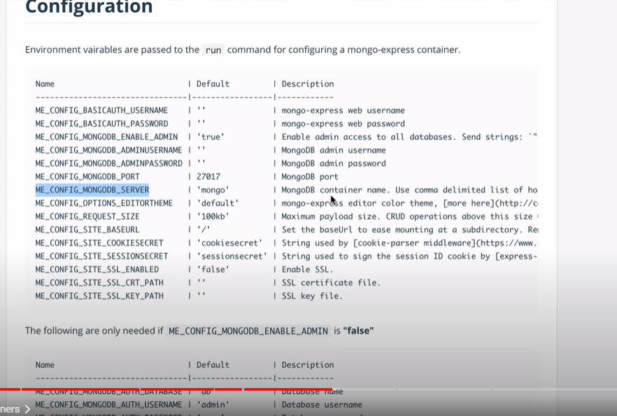

Command to run mongoExpress and connect it to MongoDB

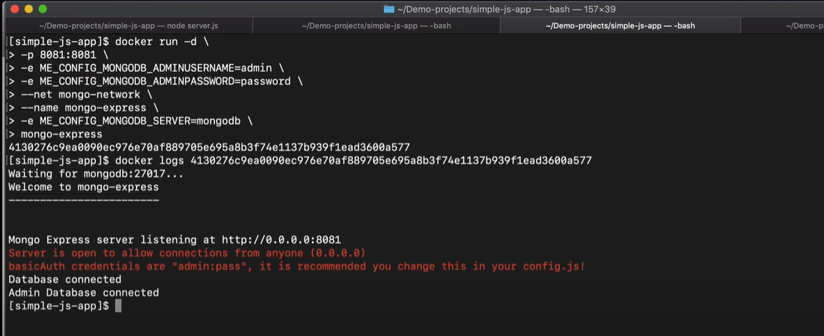

MongoExpress UI running on port 8081

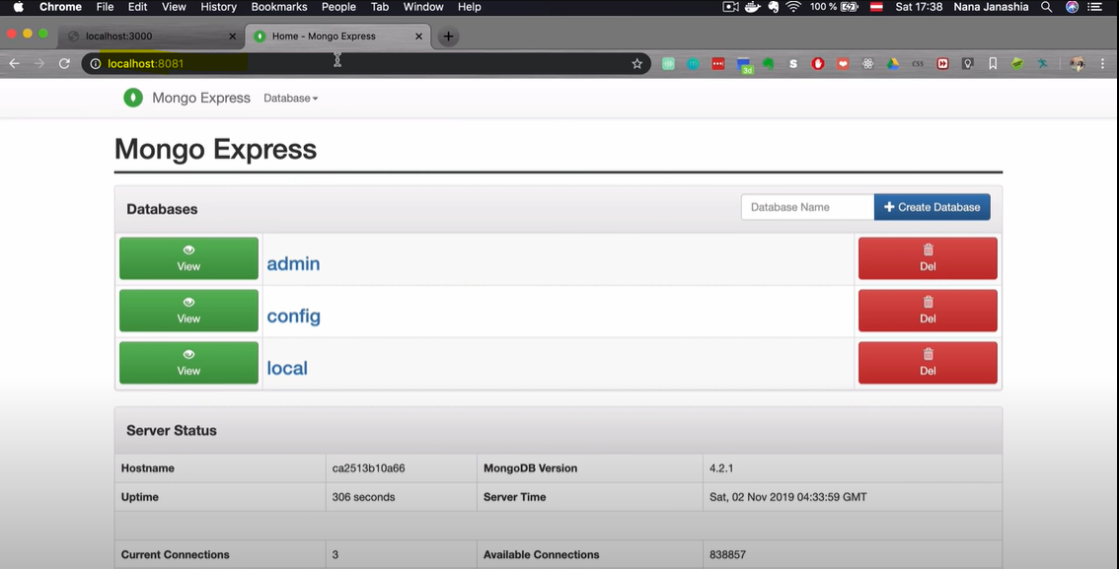

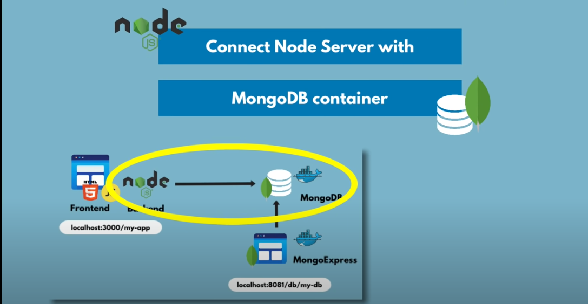

Nodejs code to connect to MongoDB at port 27017

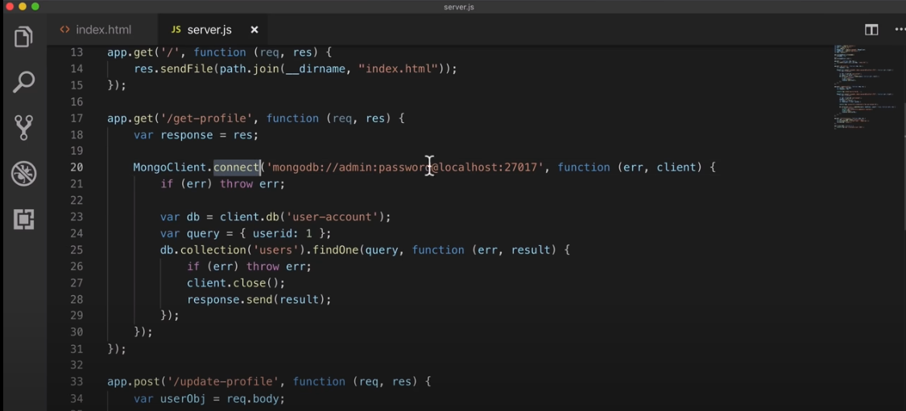

Record created in database

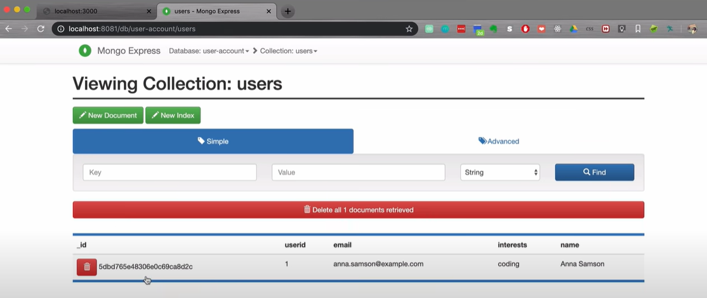

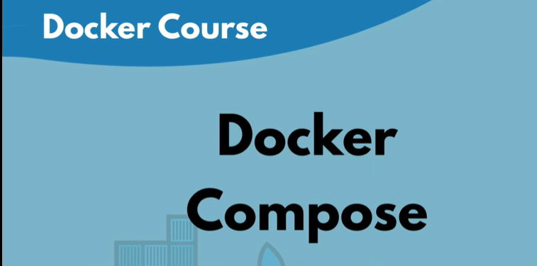

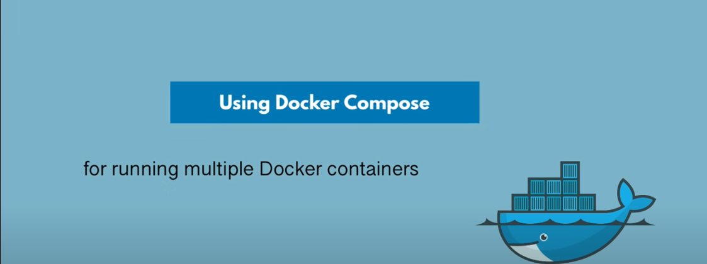

Below are the commands to create docker network and run mongoDB and mongoExpress

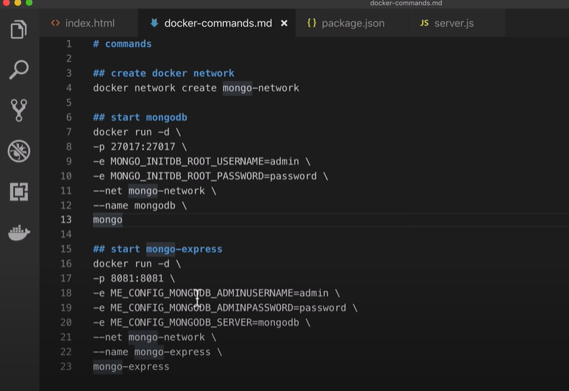

This way of starting the containers using commands is tedious and we don’t want to run this commands on the command line all the time.

If there are bunch of containers to be run, it's always good idea to automate or make it easier.

Docker compose tool helps to run this bunch of containers in an easier manner

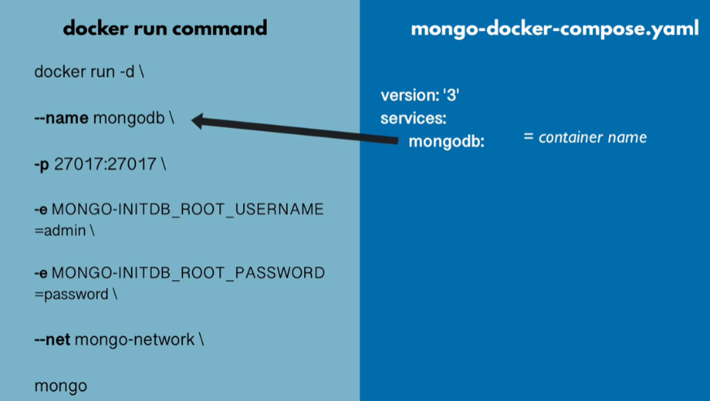

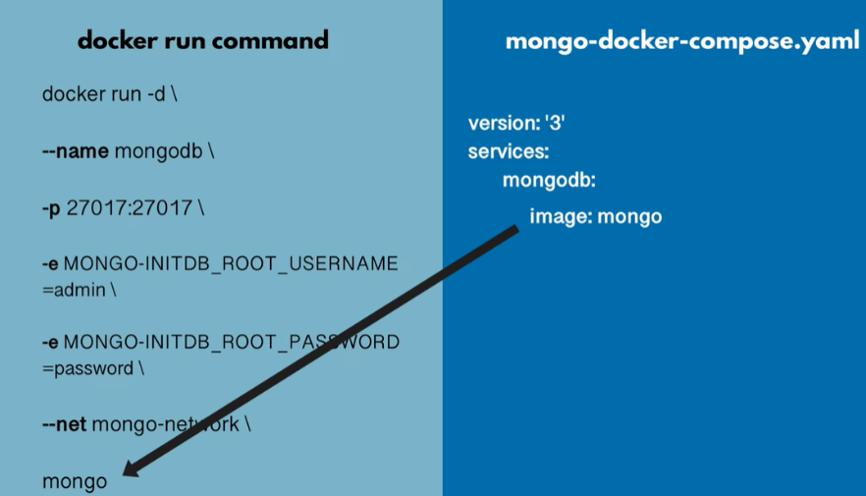

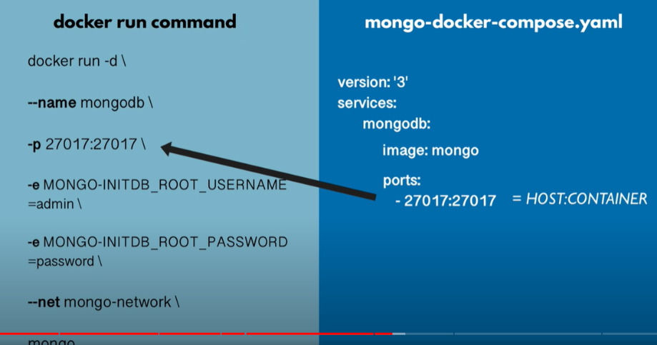

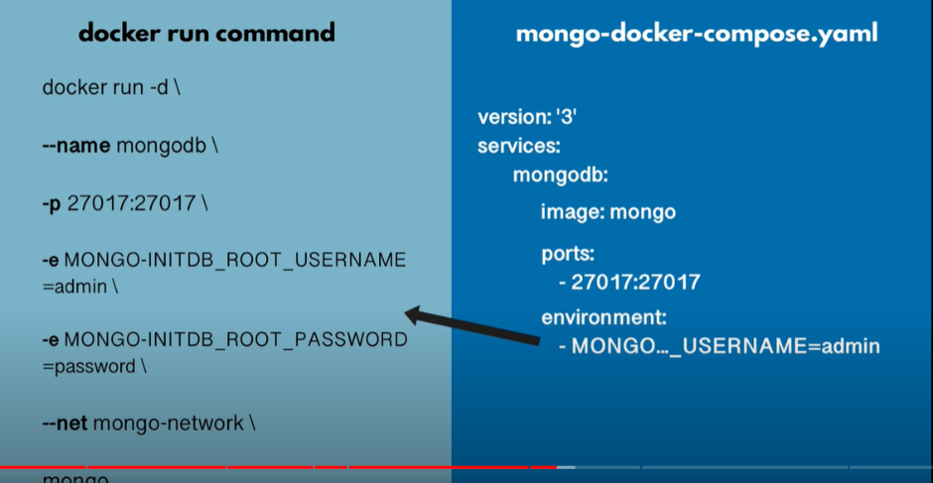

Docker compose consisting of mongoDB details and MongoExpress details

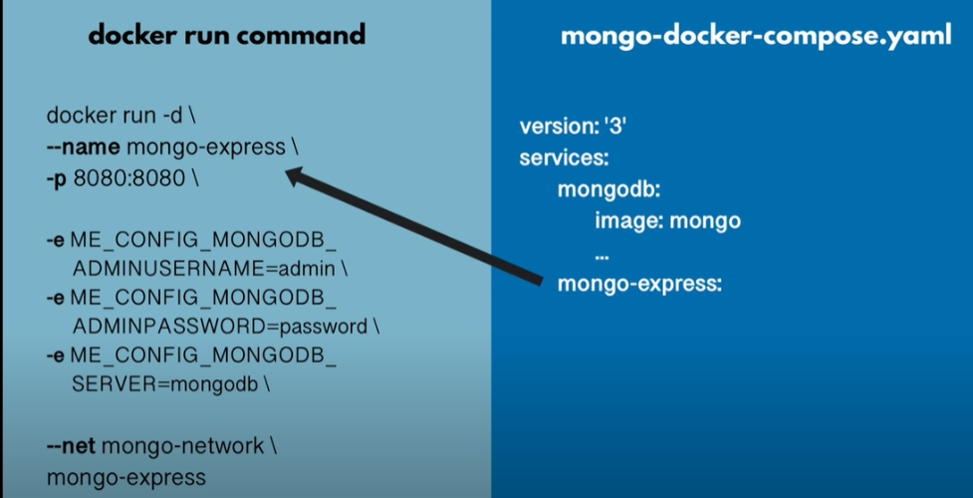

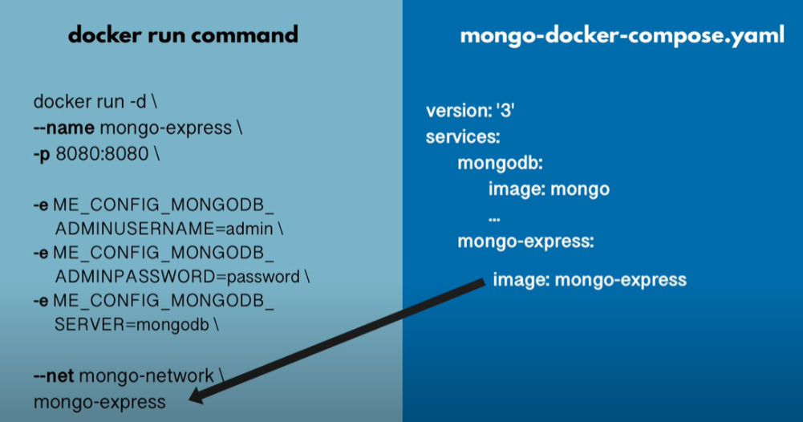

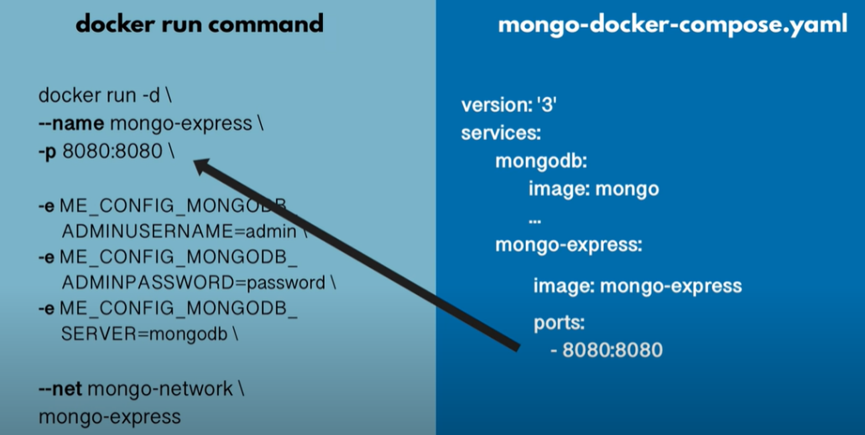

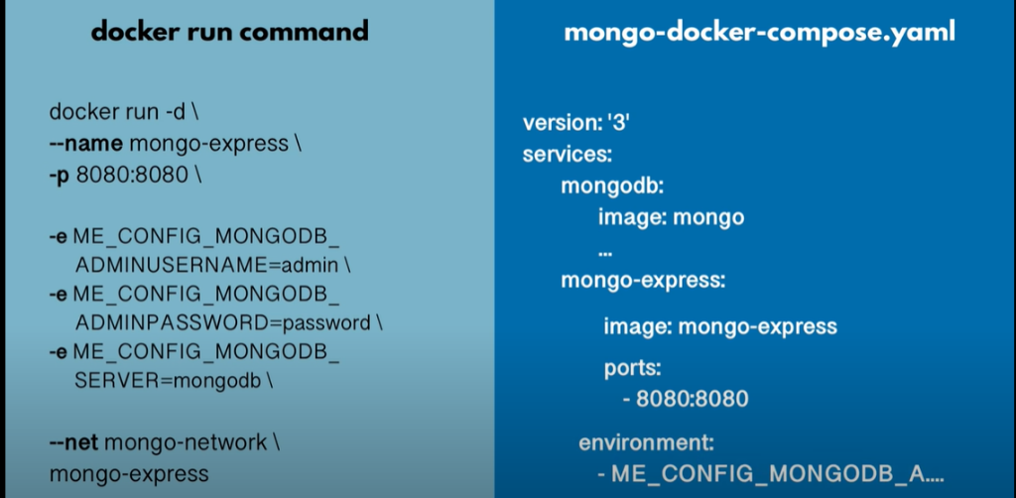

Note: network configuration is not part of docker-compose yaml file.

However docker compose takes care of creating common network for the containers mentioned inside it to communicate with each other

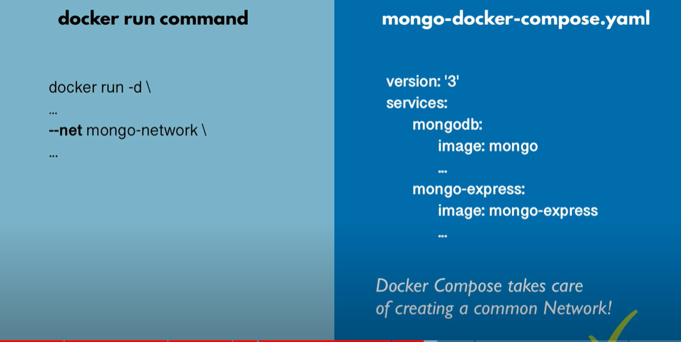



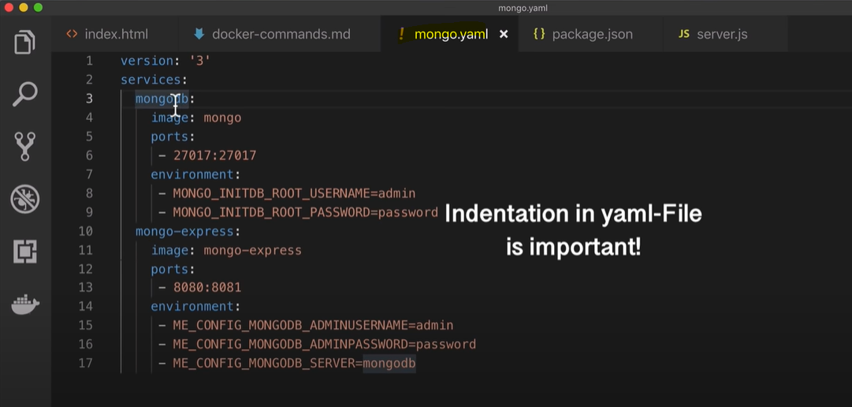

How to start the containers using docker compose ?

Command to run containers using docker compose

docker-compose -f <file_name> up

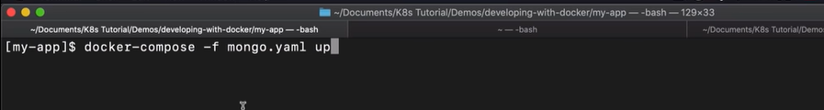

Creates a network called myapp_default and runs the containers with network name prefixed to them

<network_name>_<container_name>

myapp_mongodb_1

Myapp_mongo-express_1

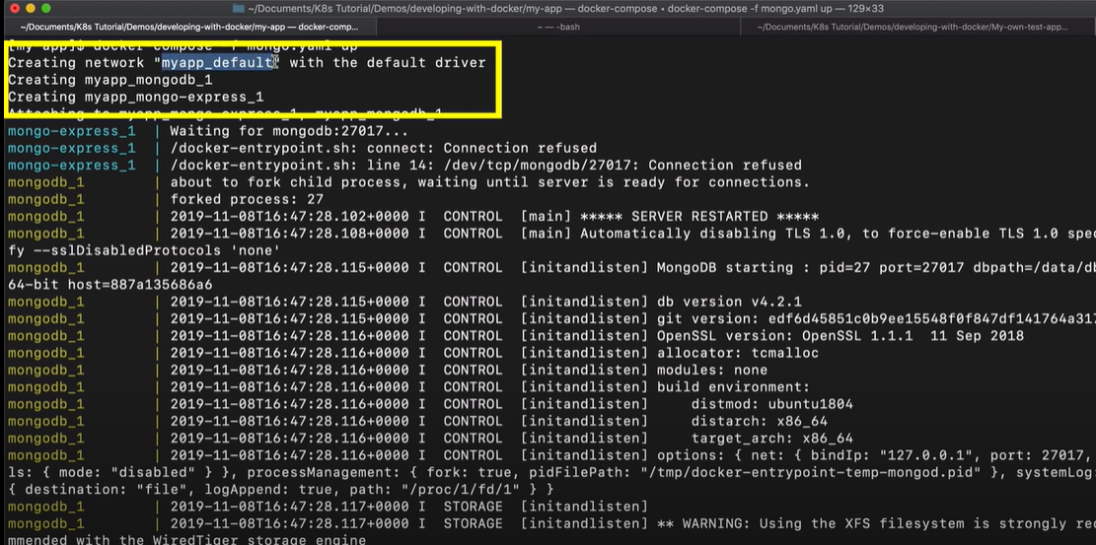

Logs of both the containers are printed simultaneously.

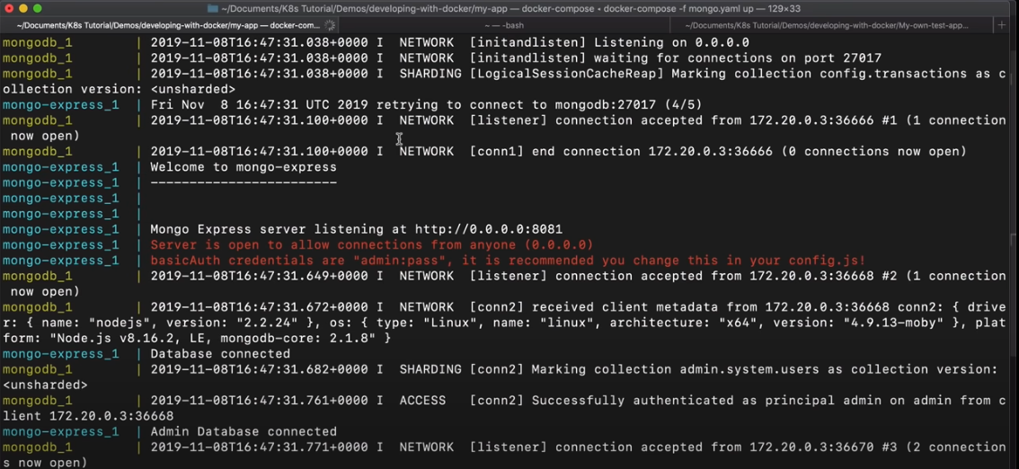

Both containers started using docker compose

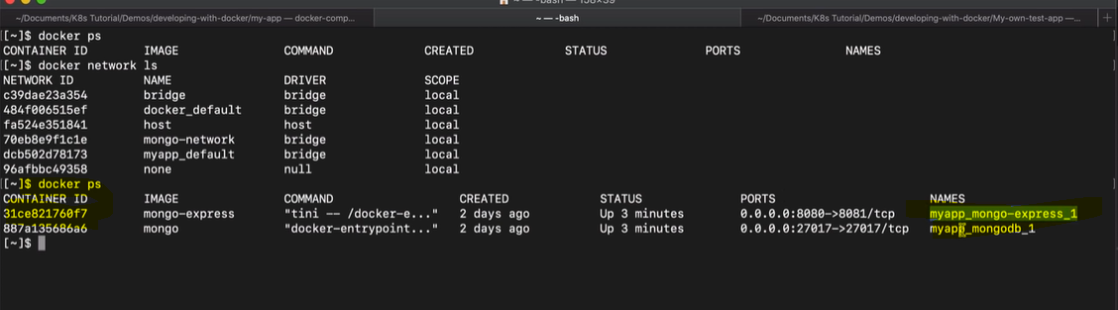

MongoExpress running on port 8080 as shown in above screenshot

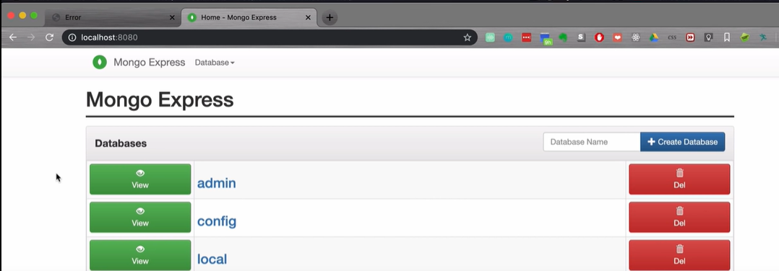

The database (user-database) and table (users) created earlier are now lost since we restarted the containers. There is no data persistance in containers.

To persist data in containers we need to use Docker Volumes

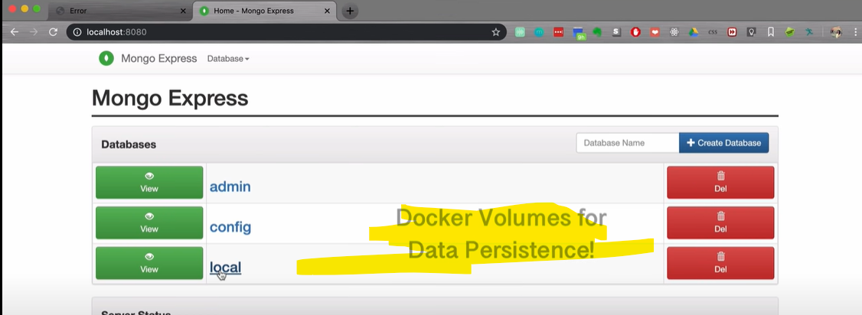

Docker compose command to stop all the containers inside it

docker-compose -f <file-name> down

This will also remove the network

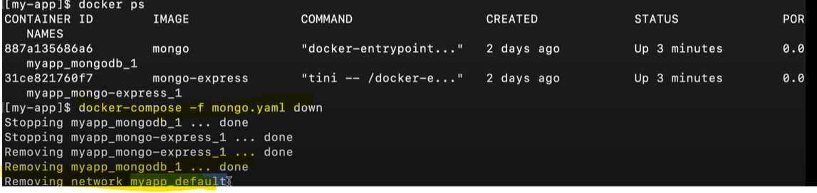

Next, Build own docker image from javascript/nodejs application i.e using docker file



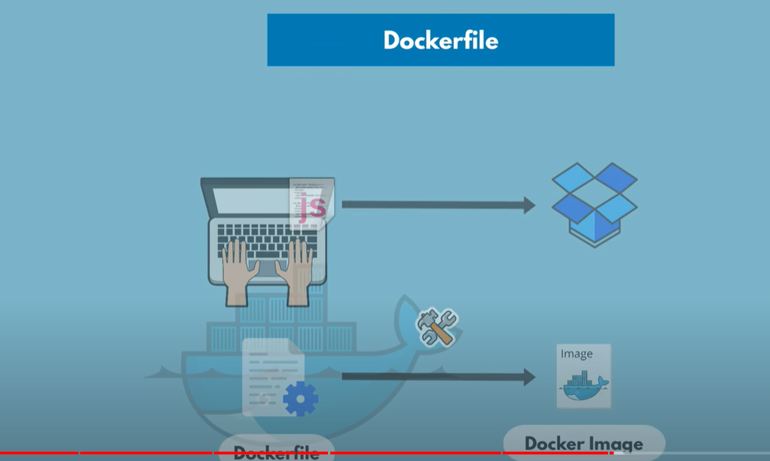

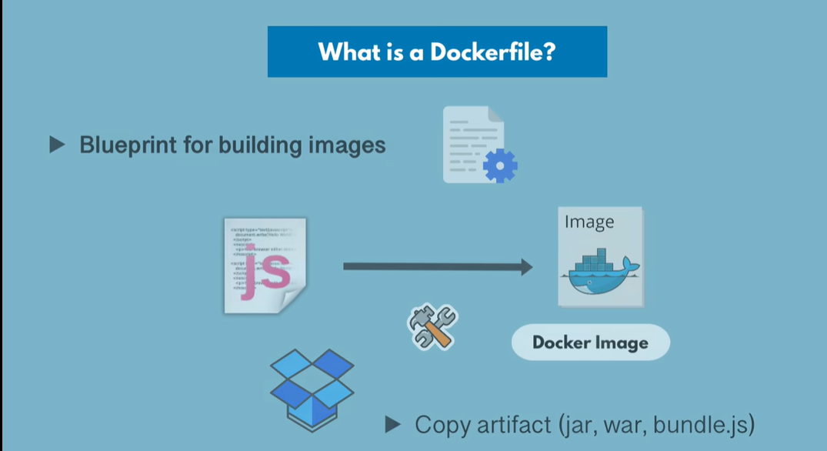

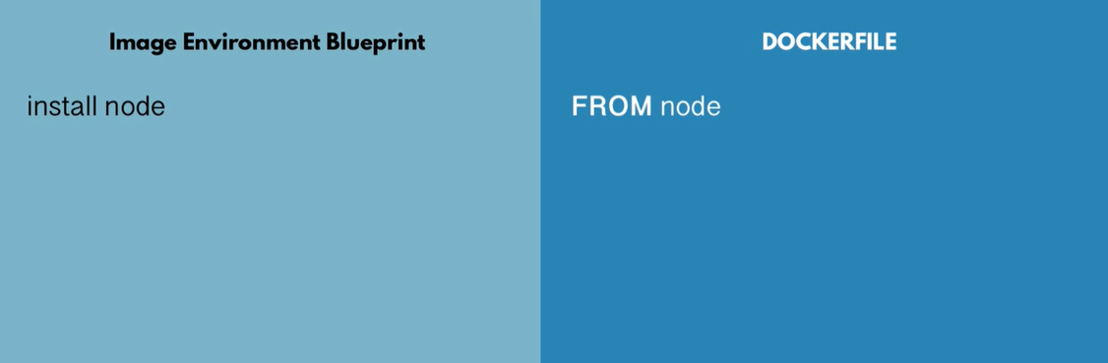

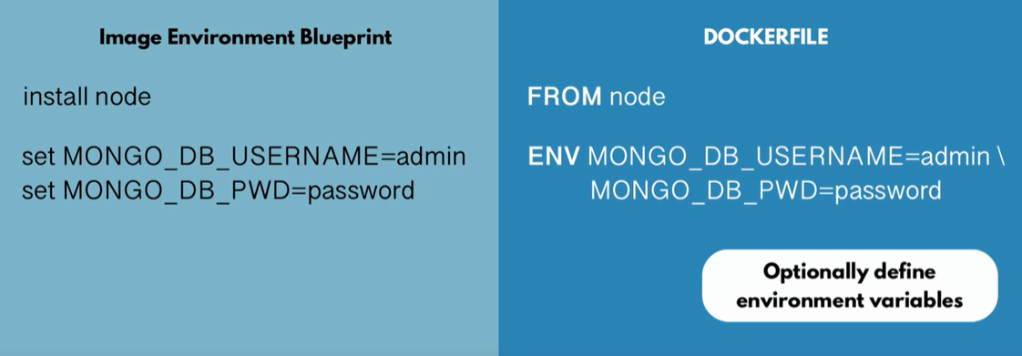

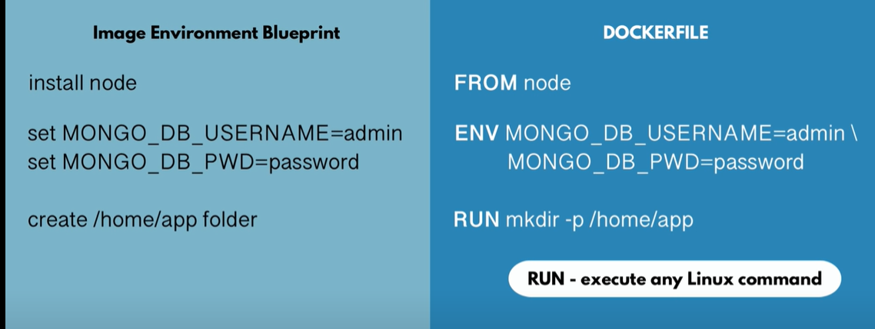

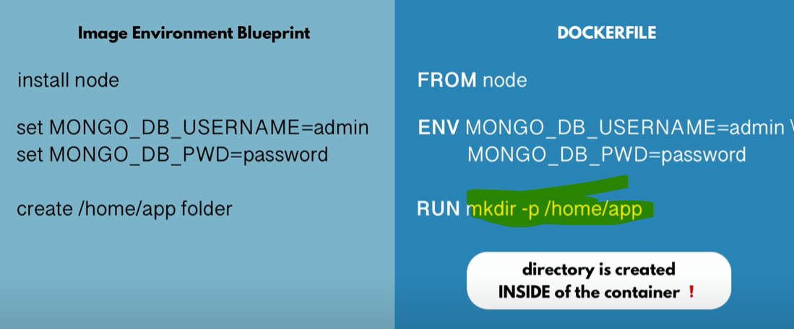

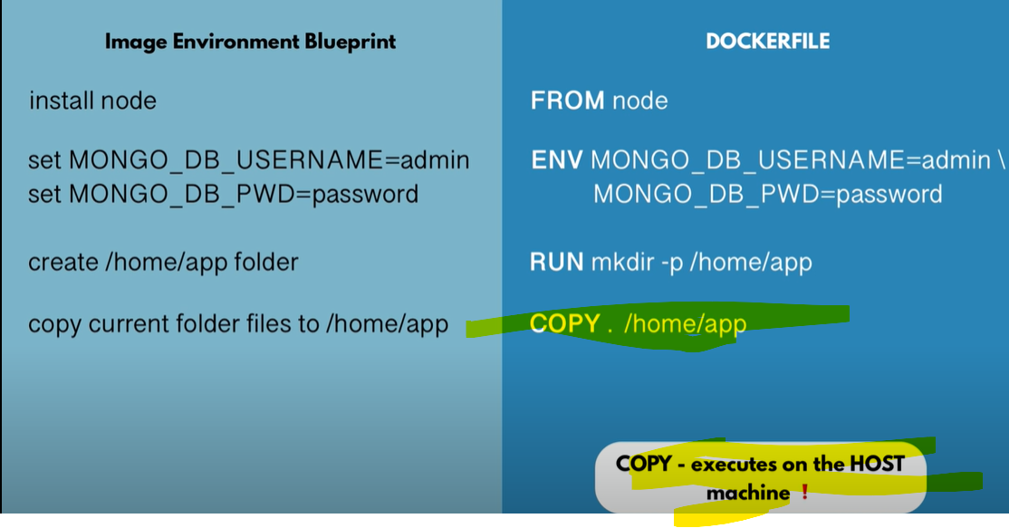

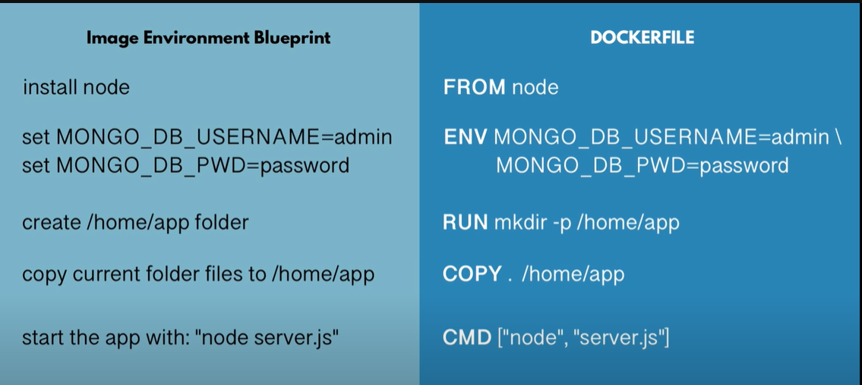

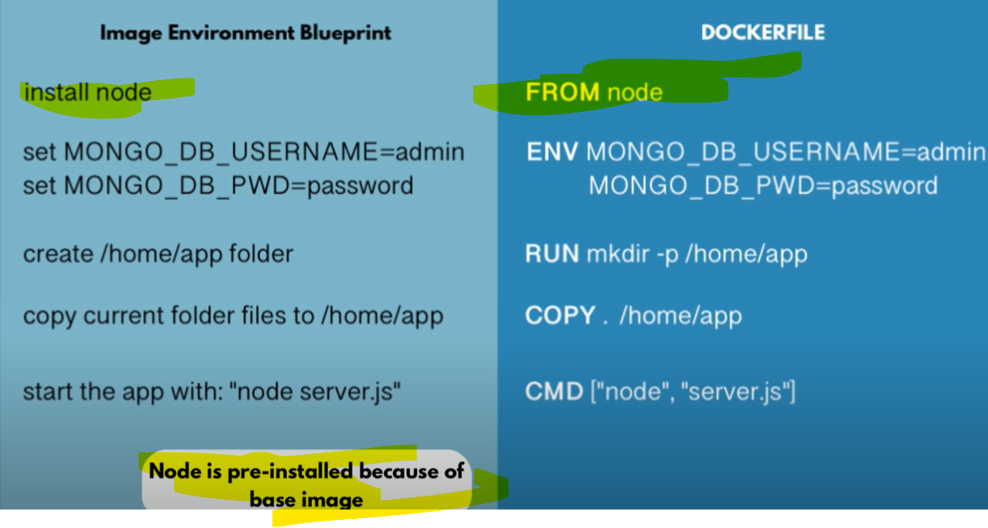

We can multiple RUN commands

But only one CMD command. CMD is the entry point

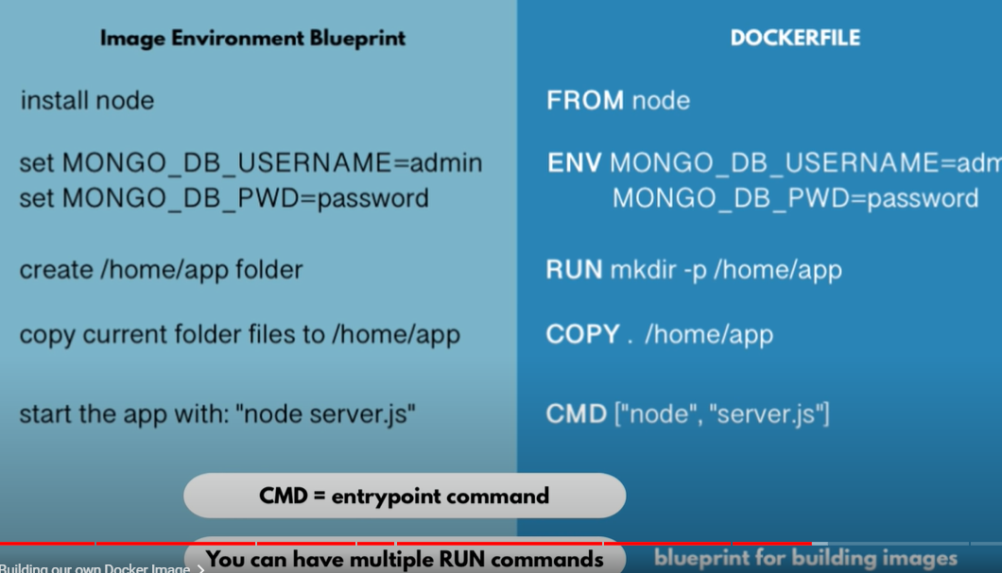



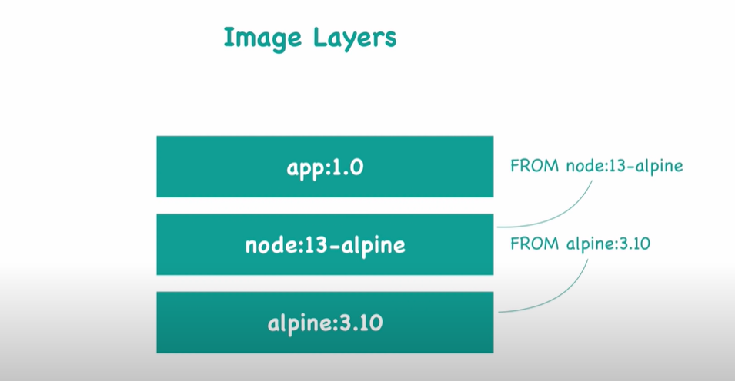

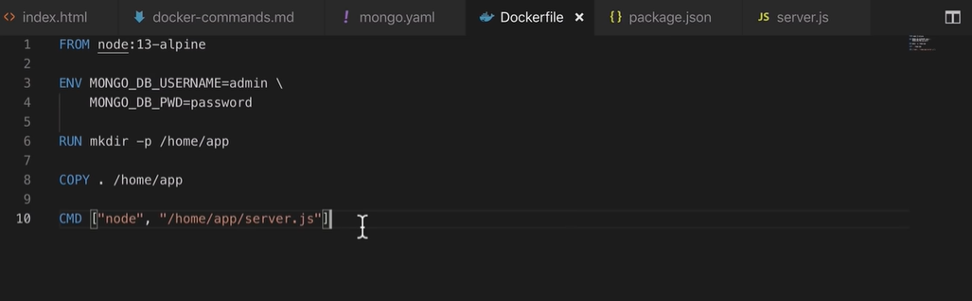

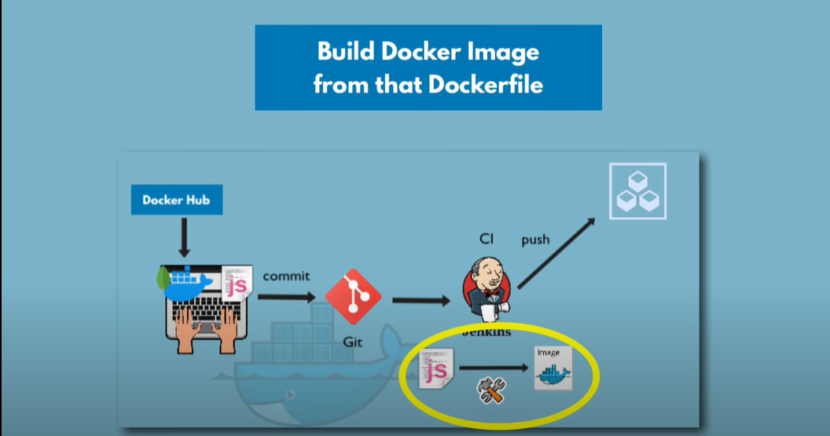

Command to build docker image from docker file

docker build -t <some_name>:<any version> <path of docker file>

docker build -t my_app:1.0 .

Highlighted is the ID of the generated docker image.

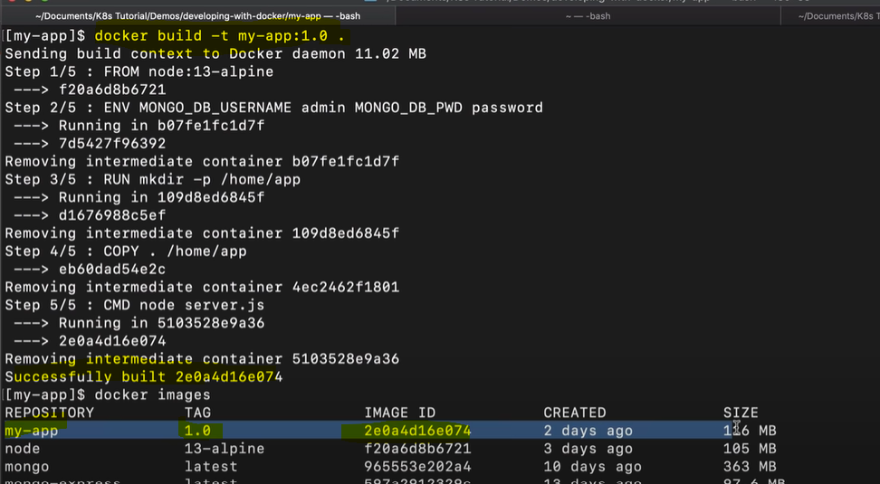

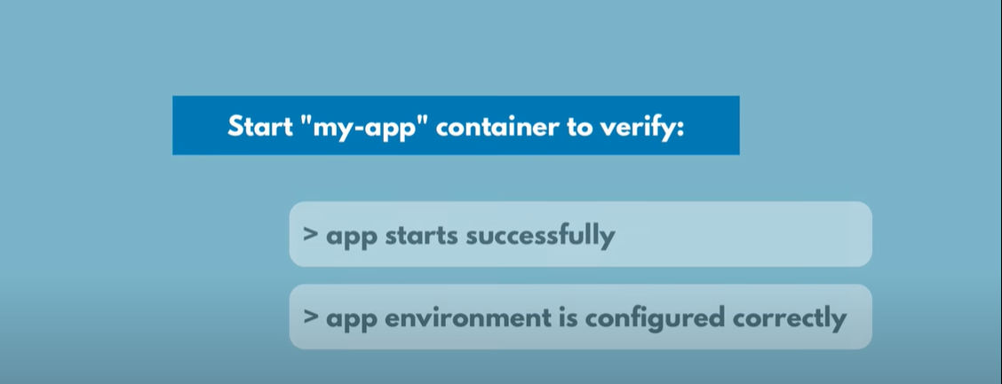

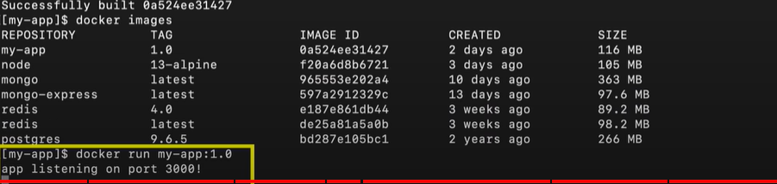

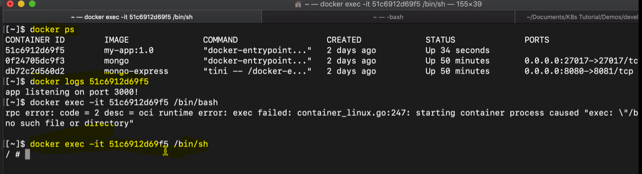



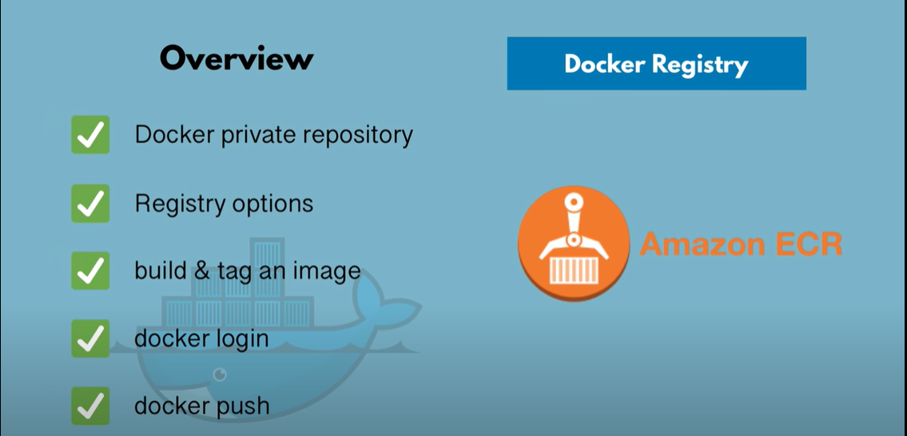



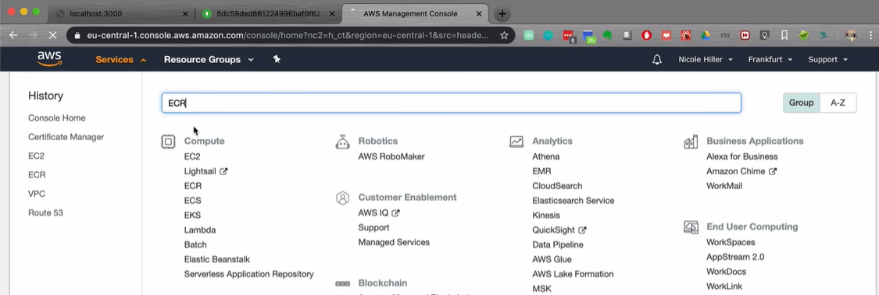

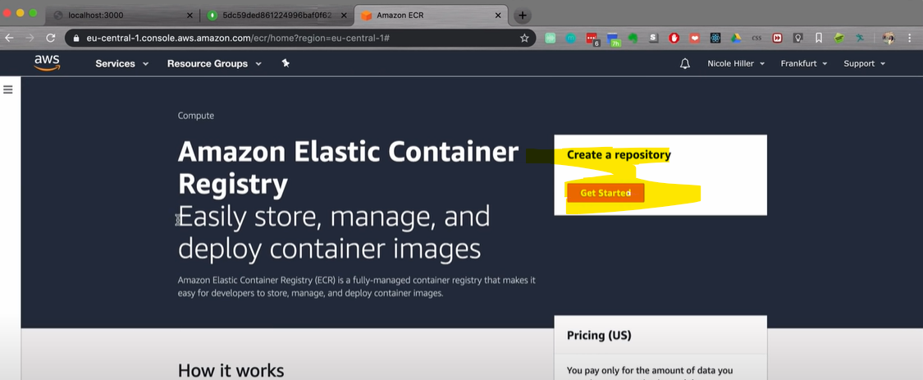

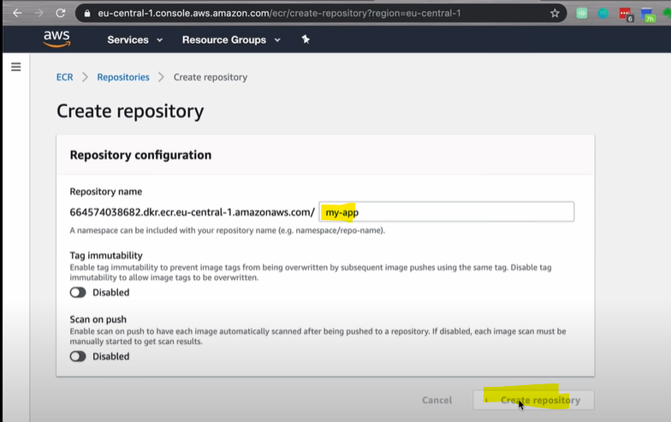

Always create repository per image.

Note: One repository can't have two different images, however can have two different versions of same image

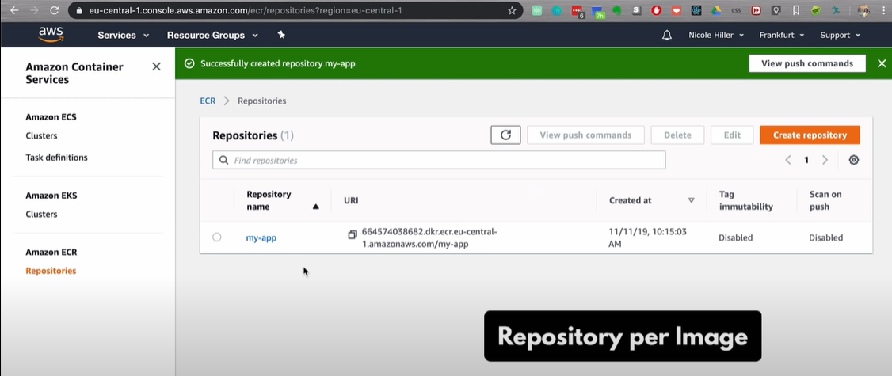

Save different versions of the same image in the repository

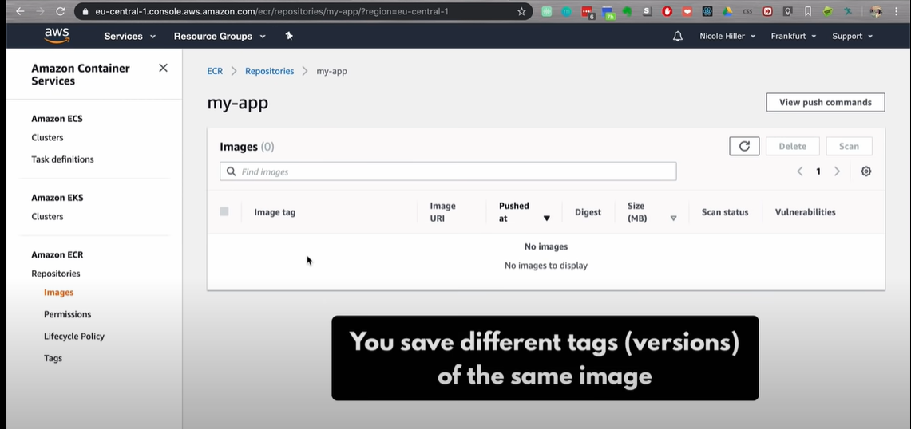

Push the docker image to aws repository

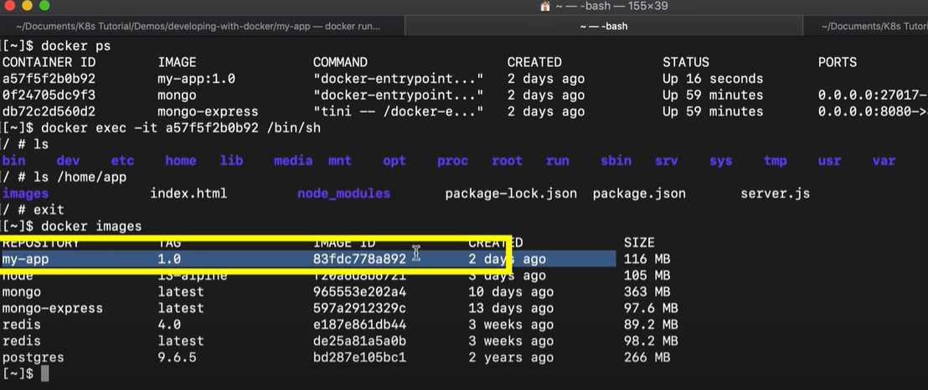

Click on the image and select View push commands as shown below

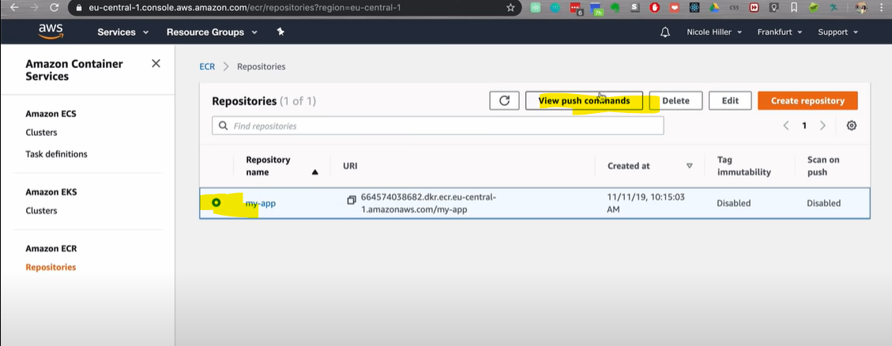

Pushing an image to aws repo

Login to private repo = docker login



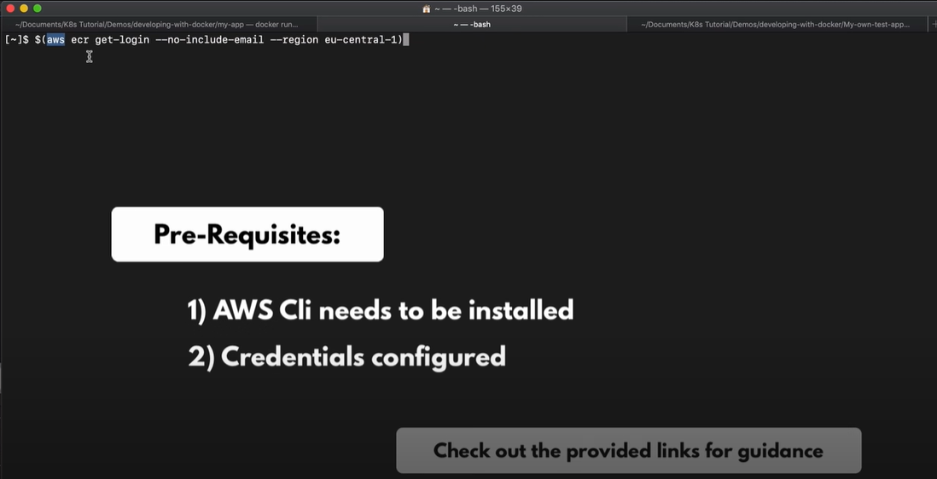

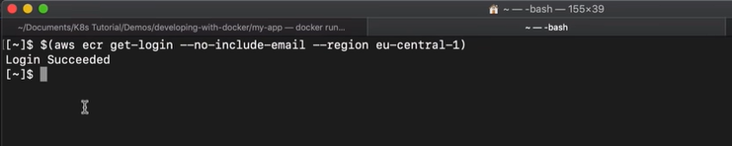

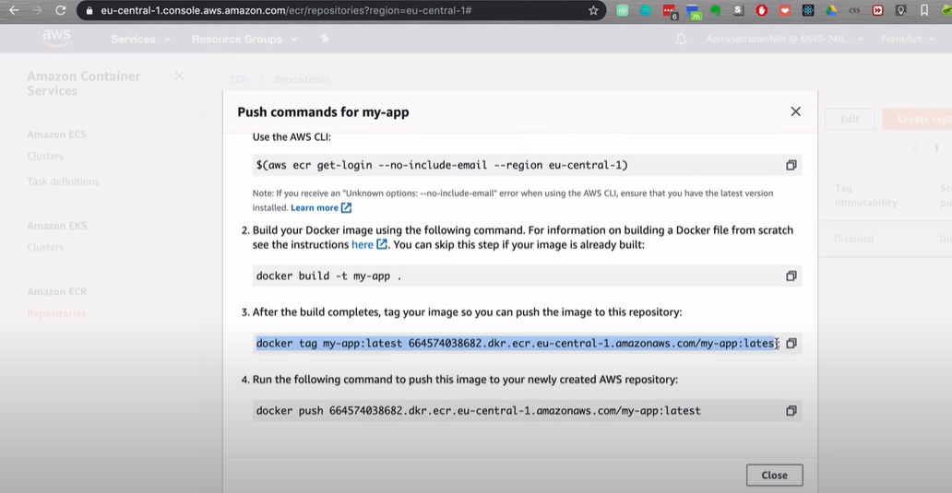

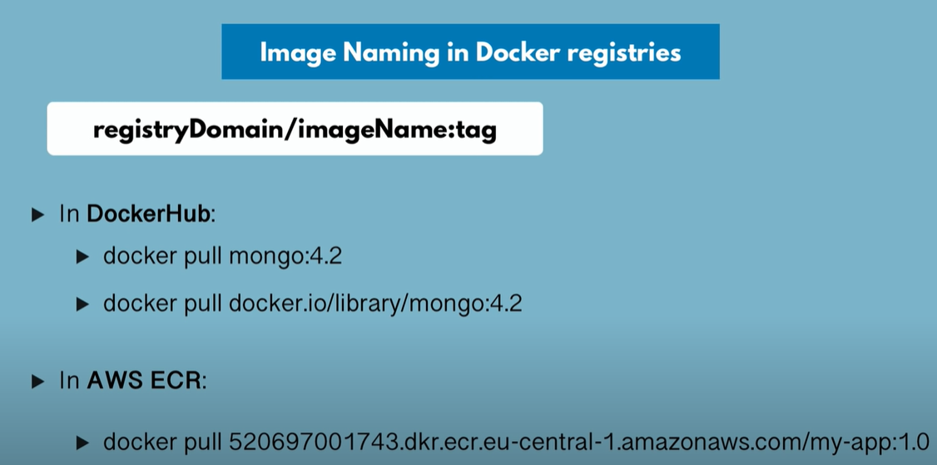

In order to push the docker image to aws repository, we need to tag the image.

Tag the image means , we rename the image to include repository, domain/address and name

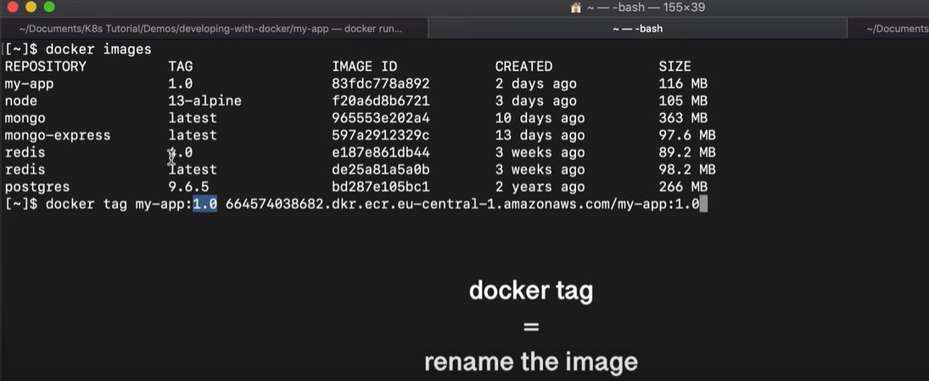

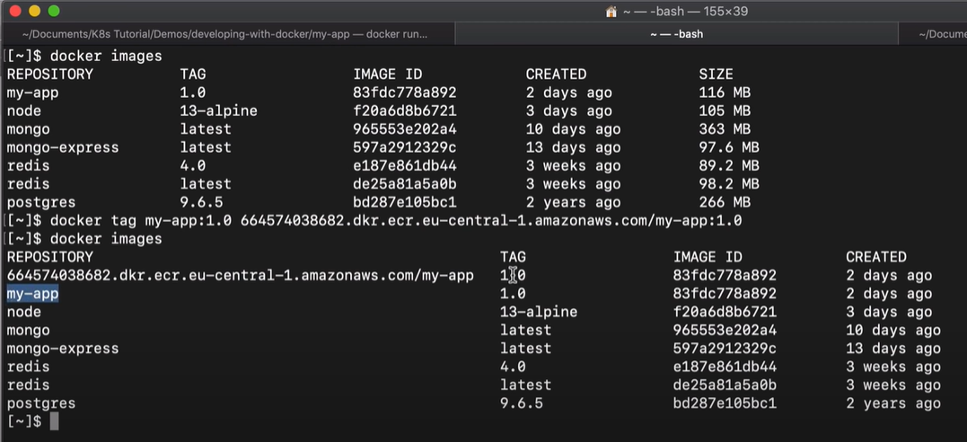

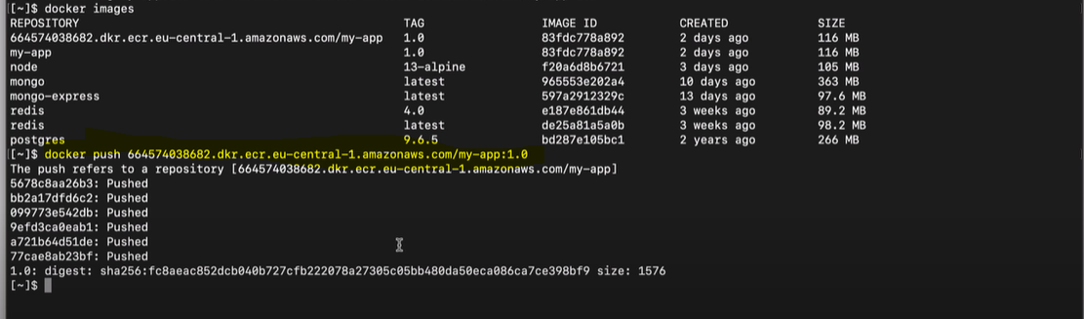

Image successfuly pushed to aws repository

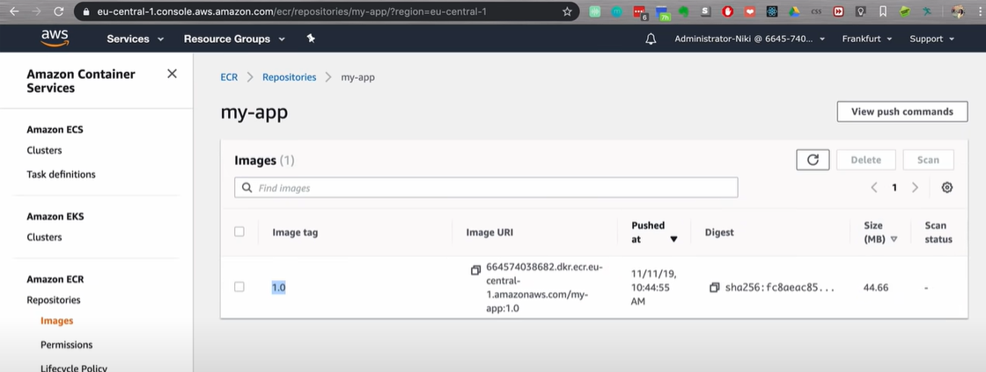



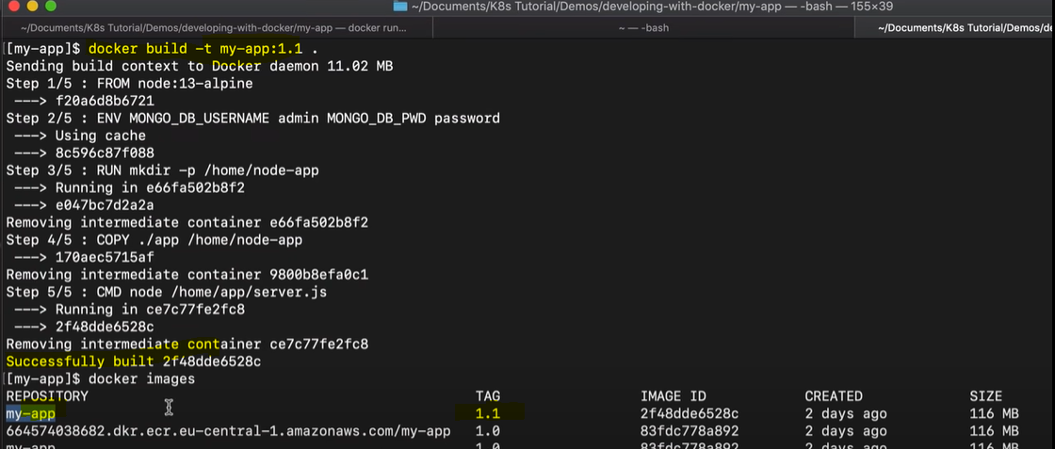

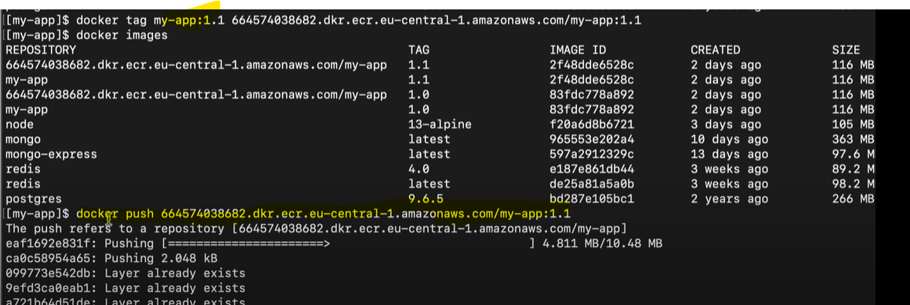

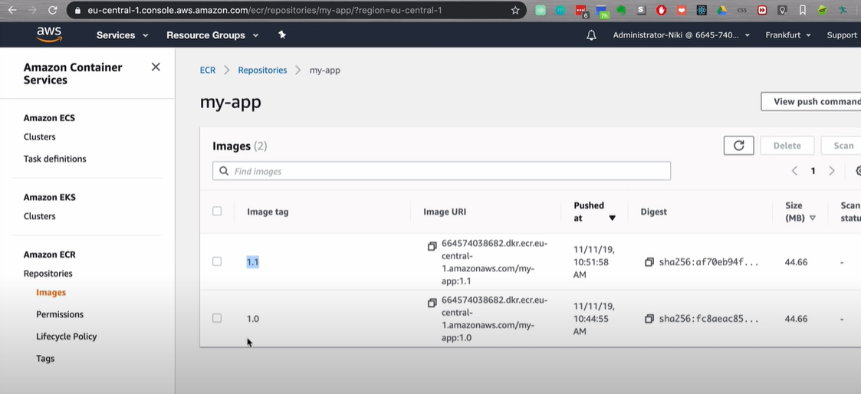

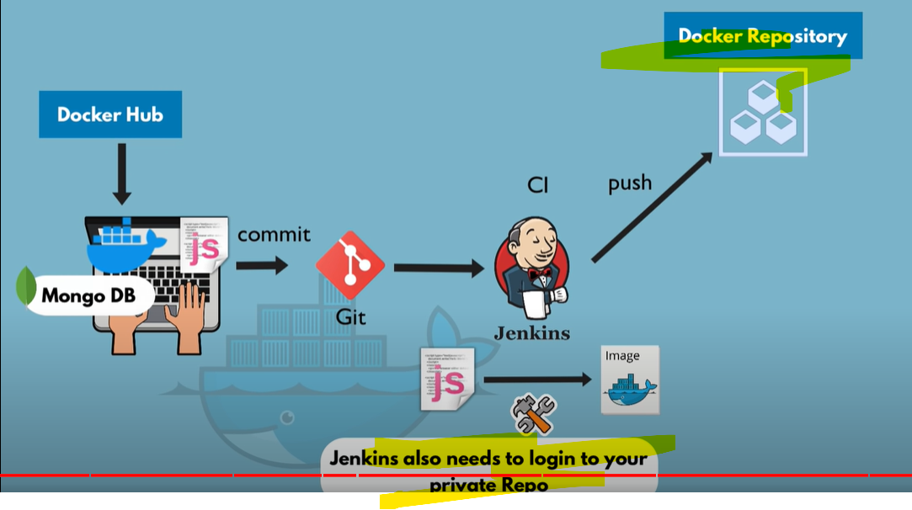

Next step is to use the image from aws and see how it is pulled from the repo

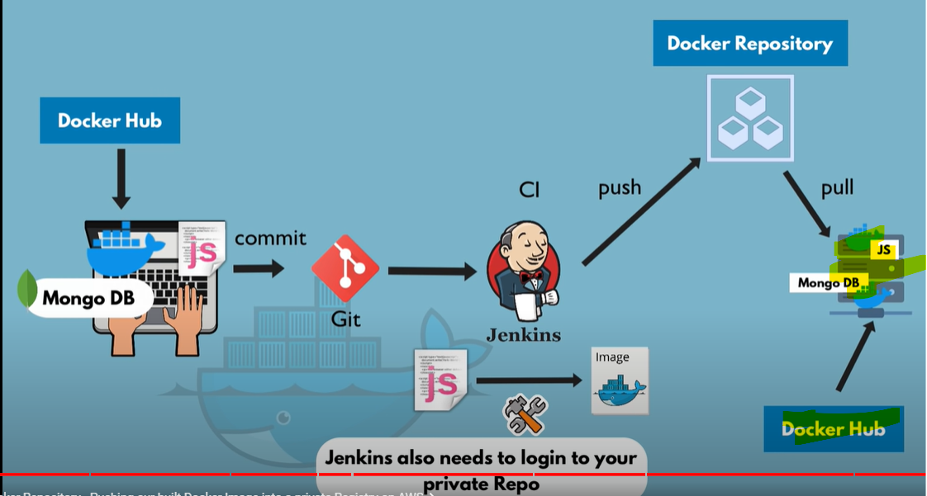

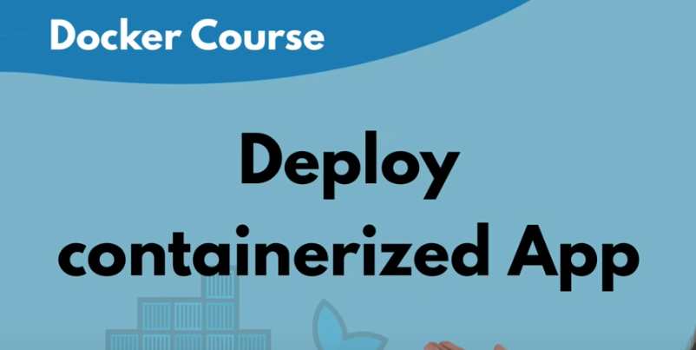

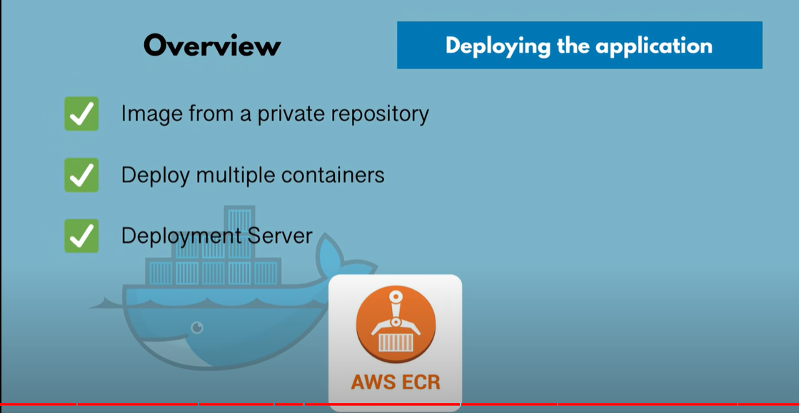

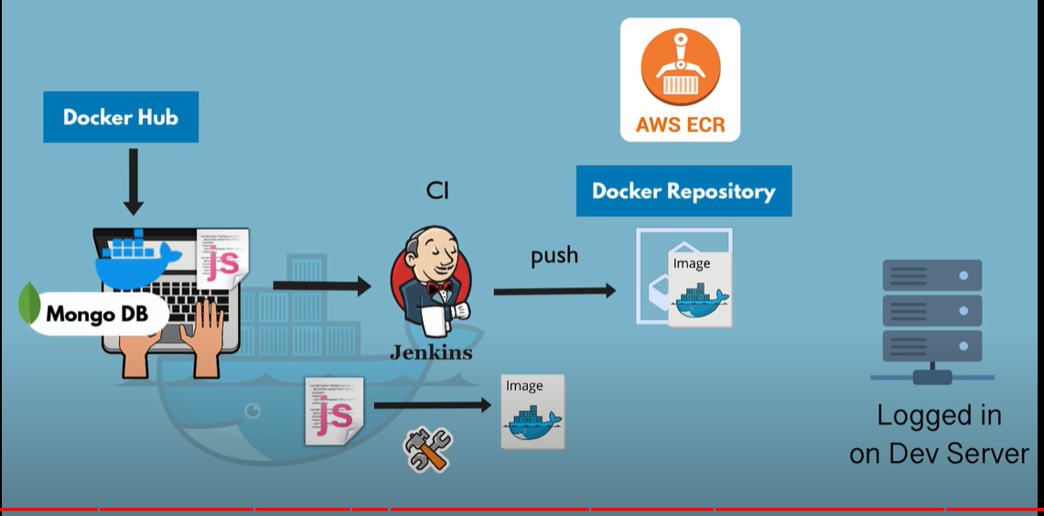

My-app image will be pulled from aws repo and MongoDB and MongoExpress images will be pulled from docker hub

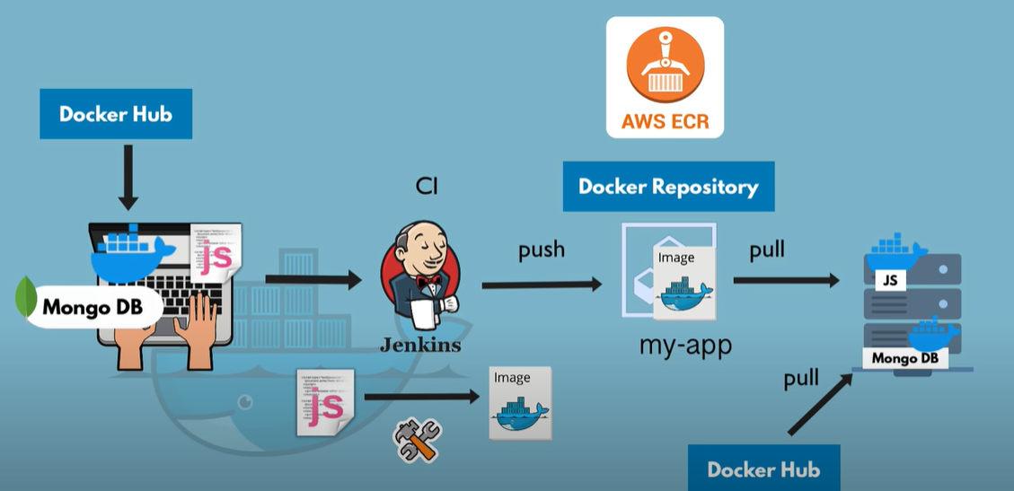

Update docker-compose with details of all images.

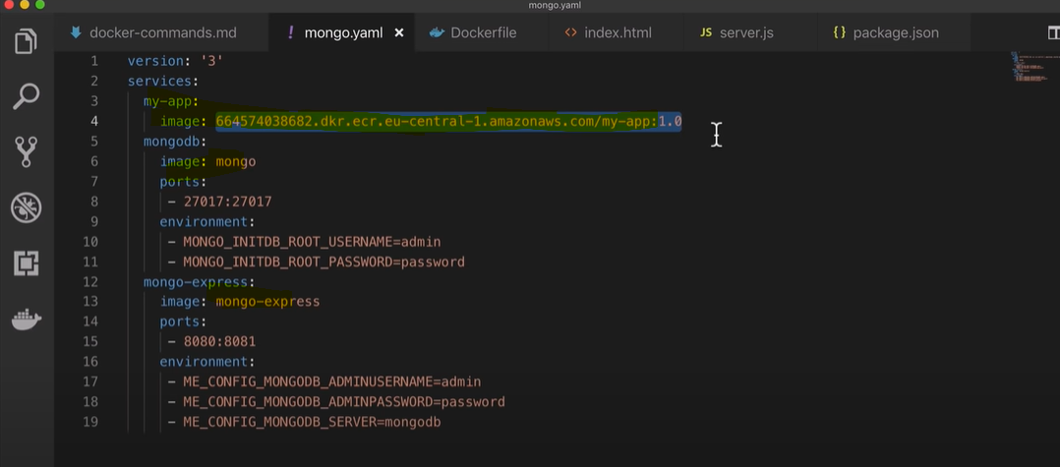

Since my-app image is a private repo. We need to provide login details

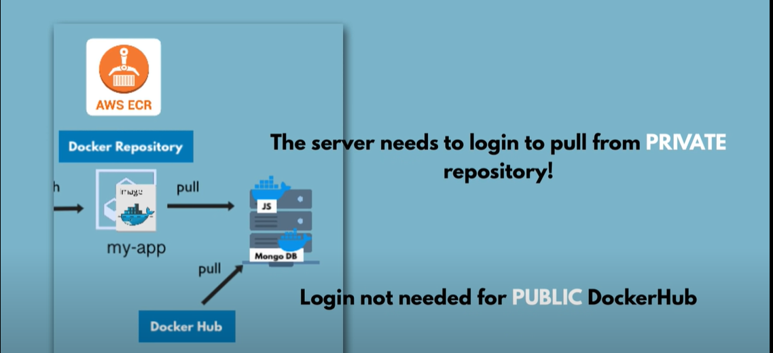

The development server need to login to private repo before we do docker-compose

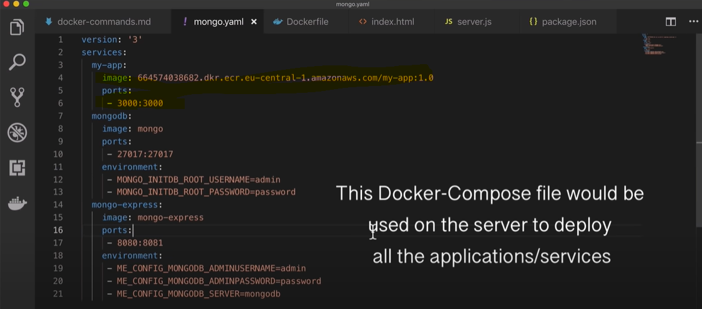

In below terminal we have already logged in to docker login.

Copy the content of docker-compose from IDE to server and start the docker-compose file

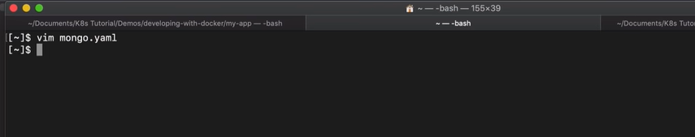

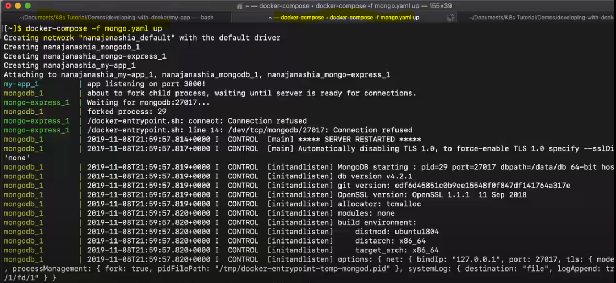

Verify if the application works

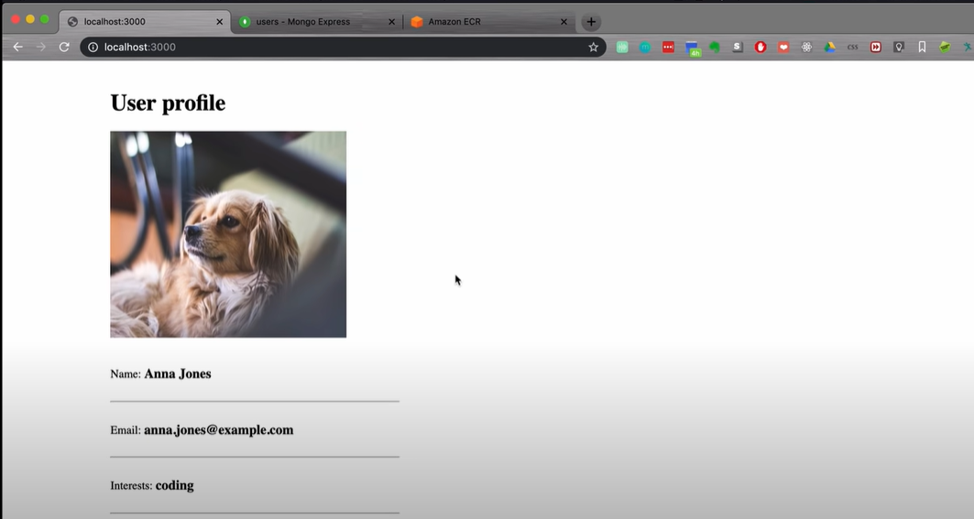

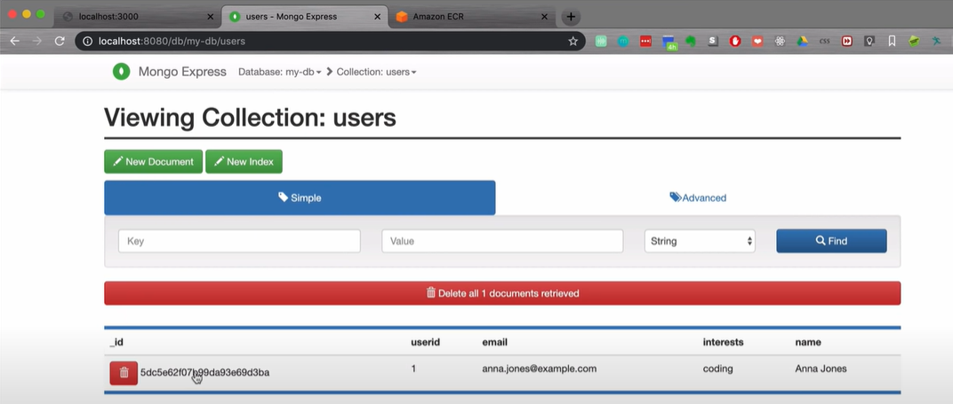





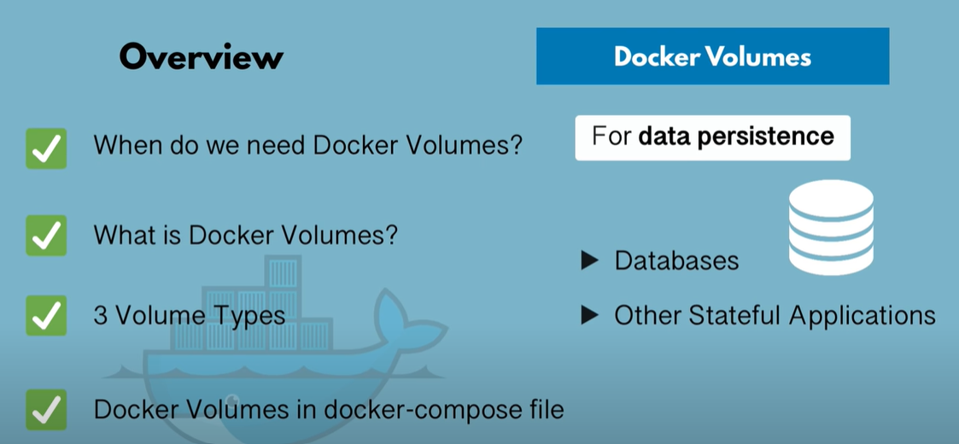

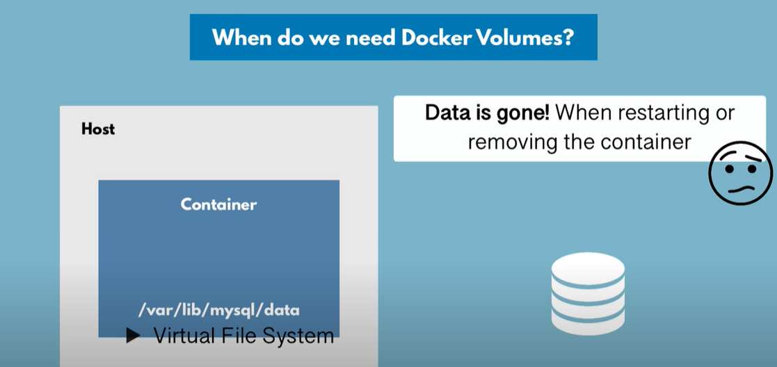

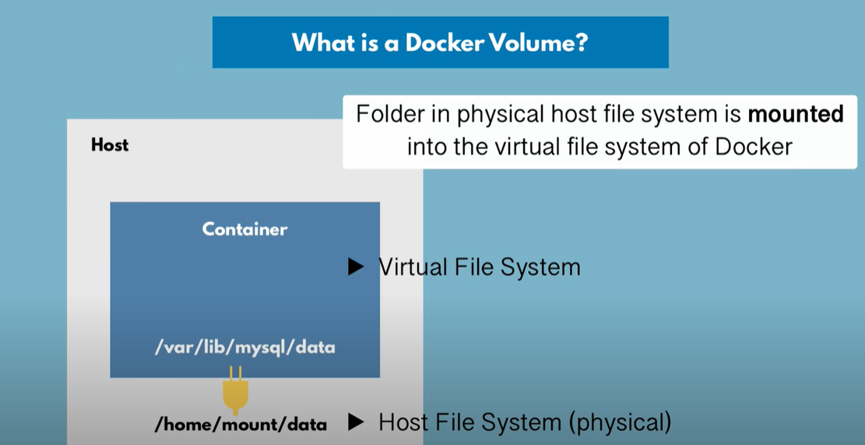

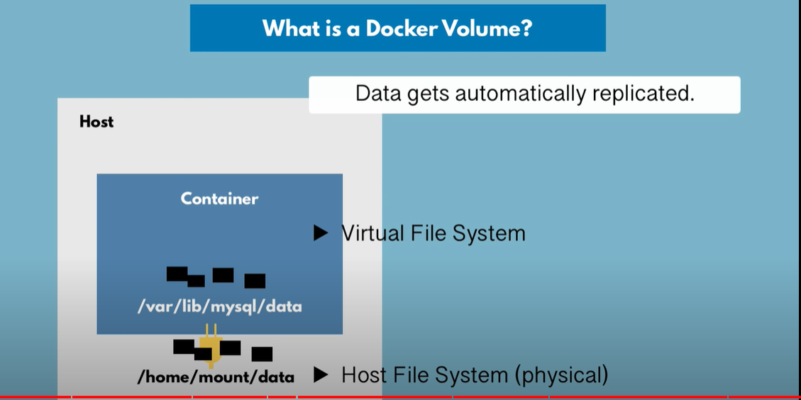

3 volume types

1.Host volumes - we define the host path where the directory to be mounted

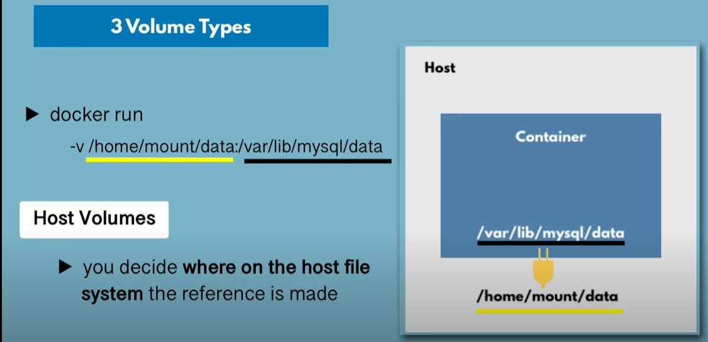

2.Anonymous volumes - docker decides the path for the host in which data is mounted

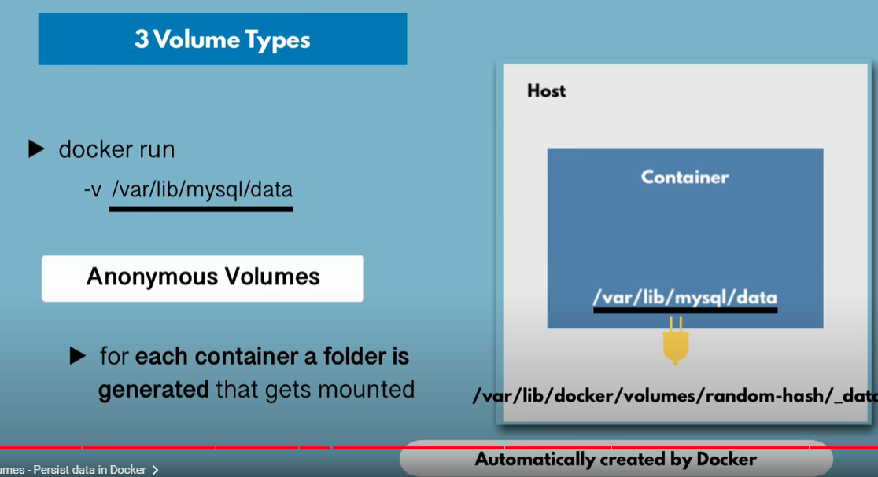

3.Named volumes - recommended to use and should be used in production

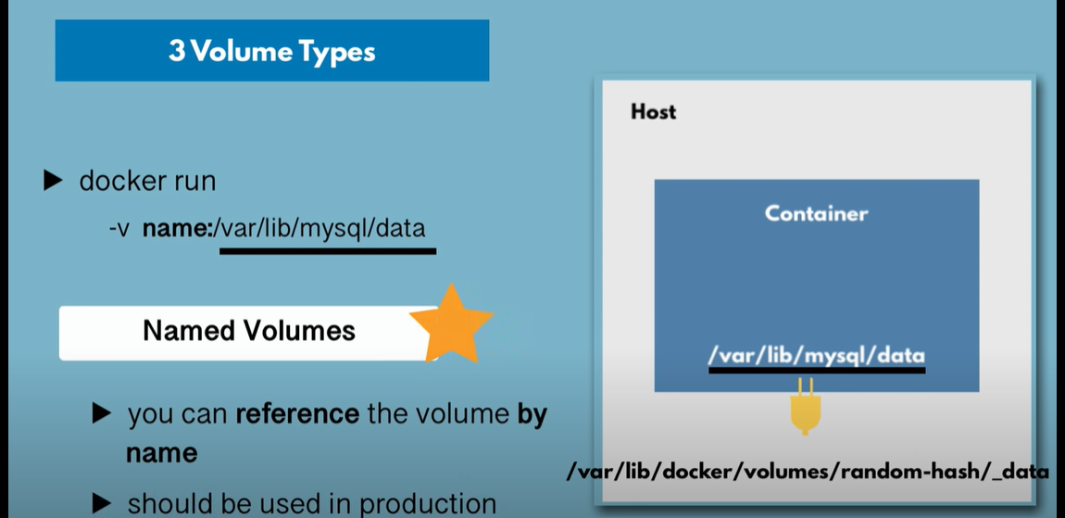

Using Named volumes from docker-compose

In below screenshot, db-data is the name of the volume(reference volume) and /var/lib/mysql/data is the path in the container

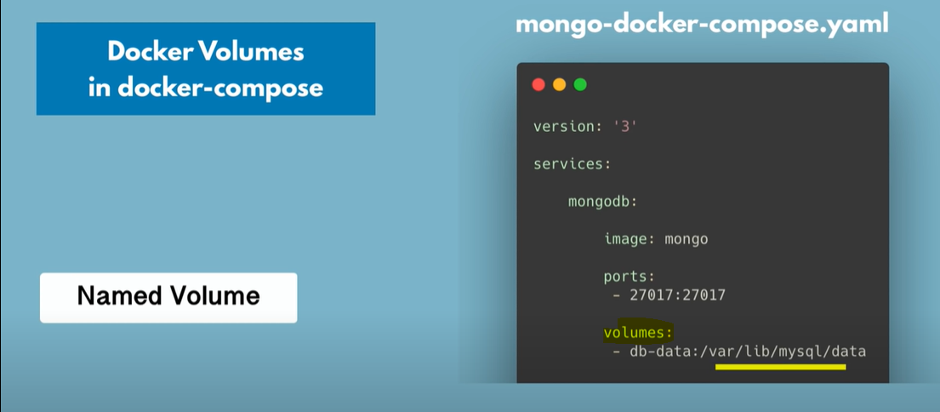

At the end of the docker-compose file, list all the volumes defined in the docker-compose

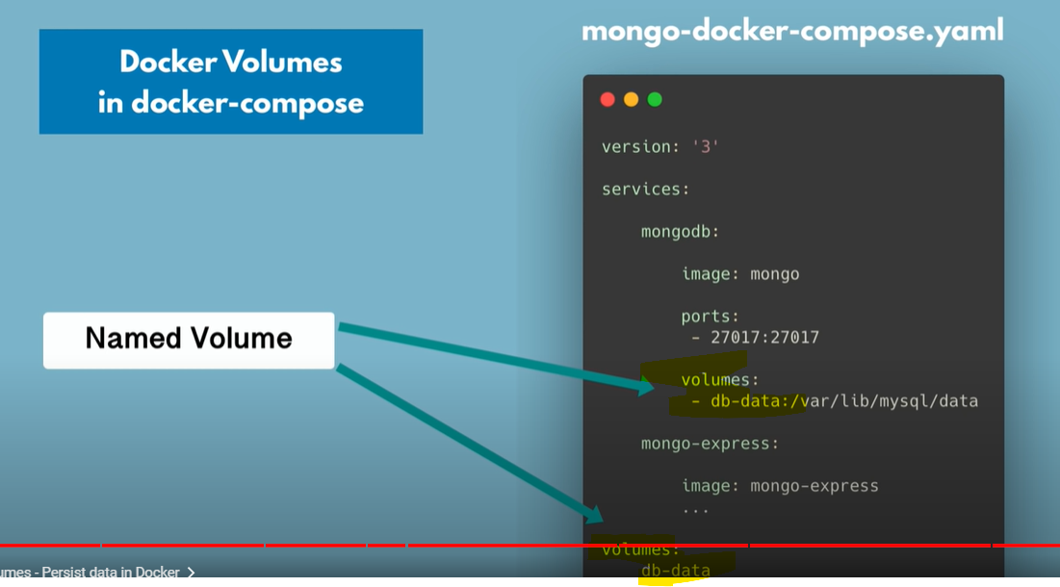





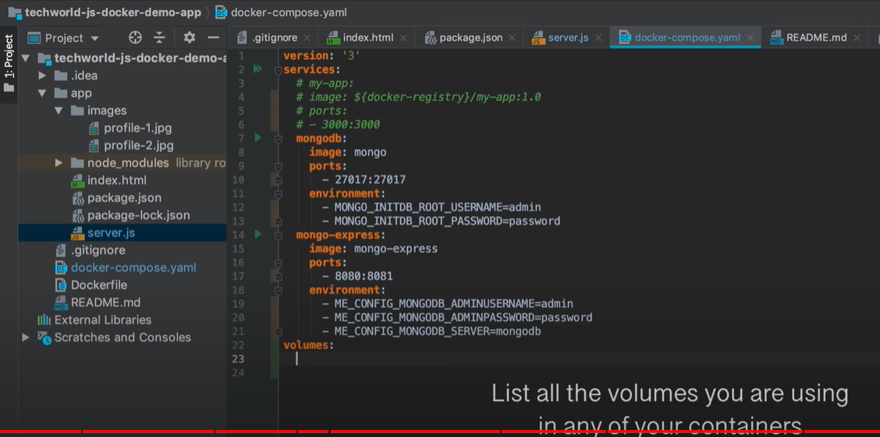

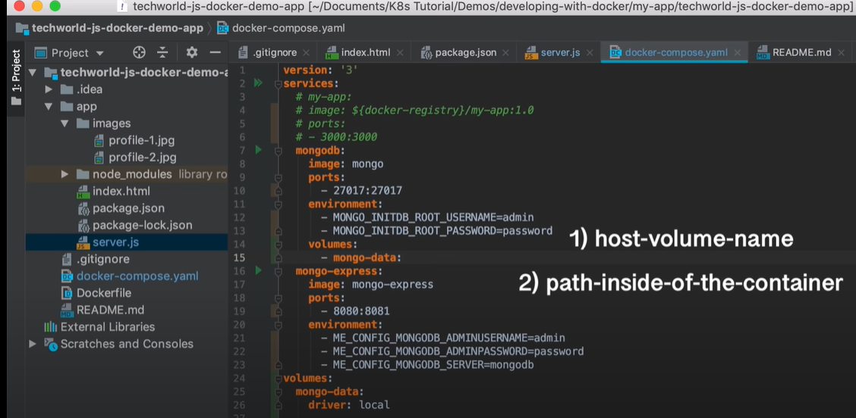

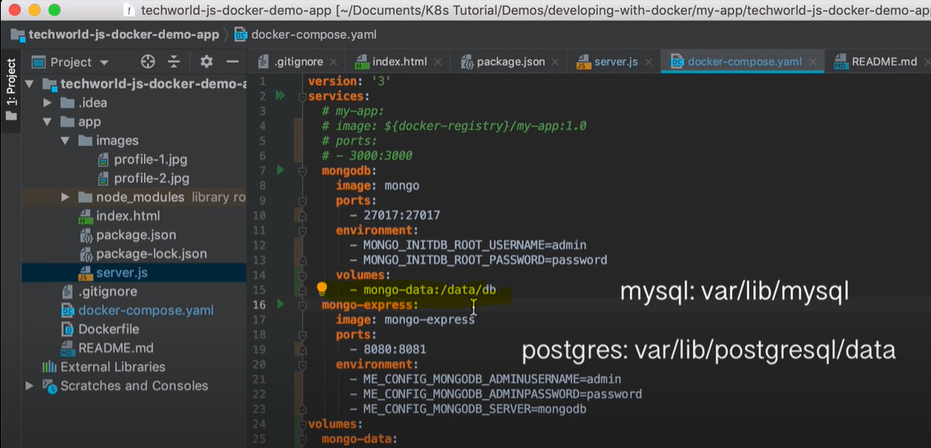

Path of mongo-db inside the container

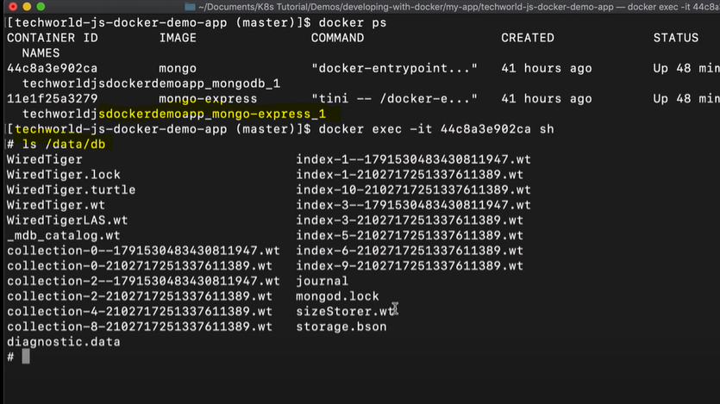



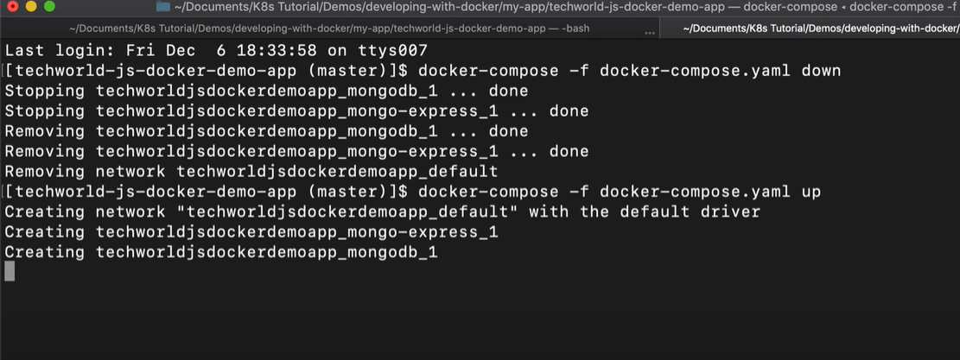

Create data and check in database

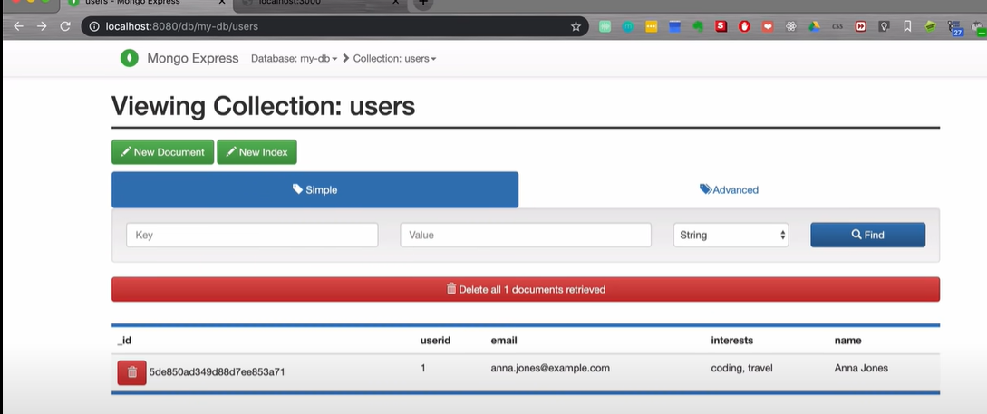

Restart the container

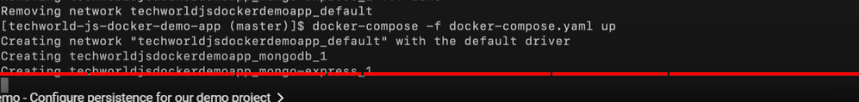

After restart, go back database and verify the data should be persisted

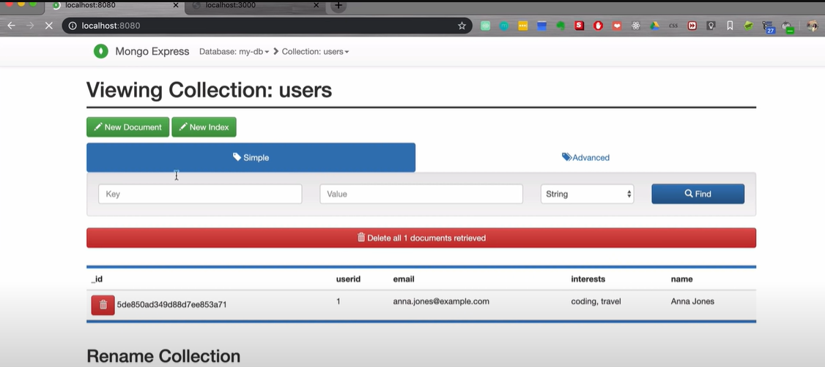



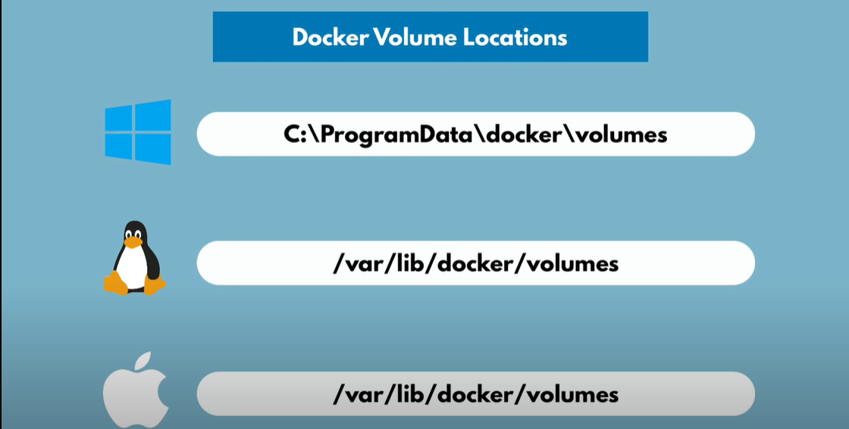

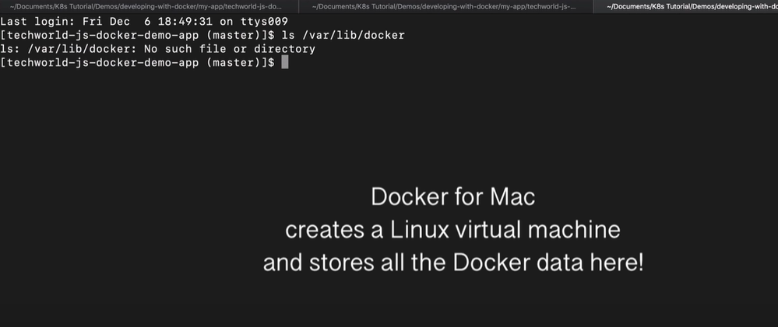

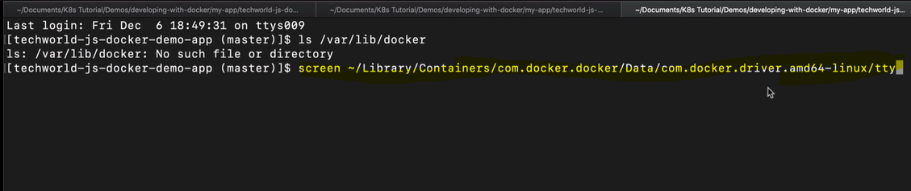

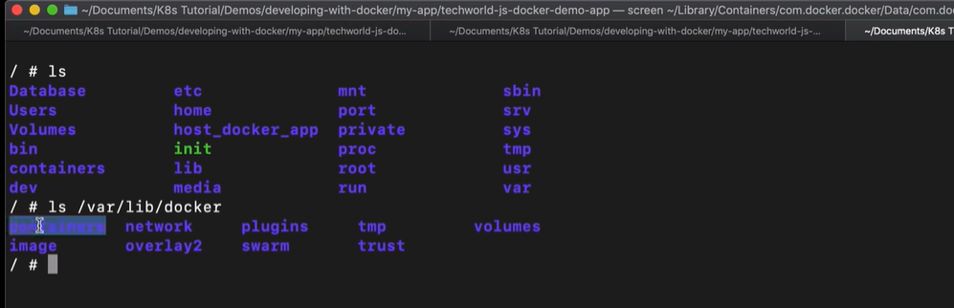

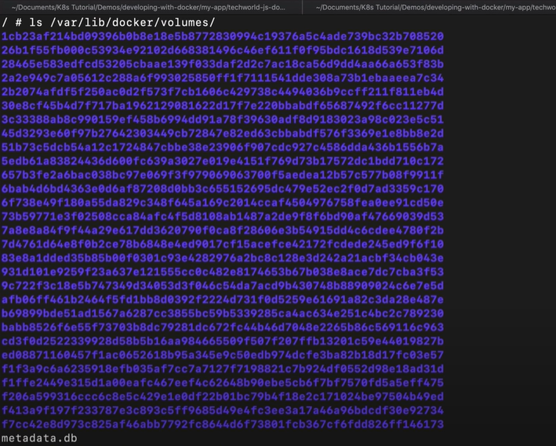

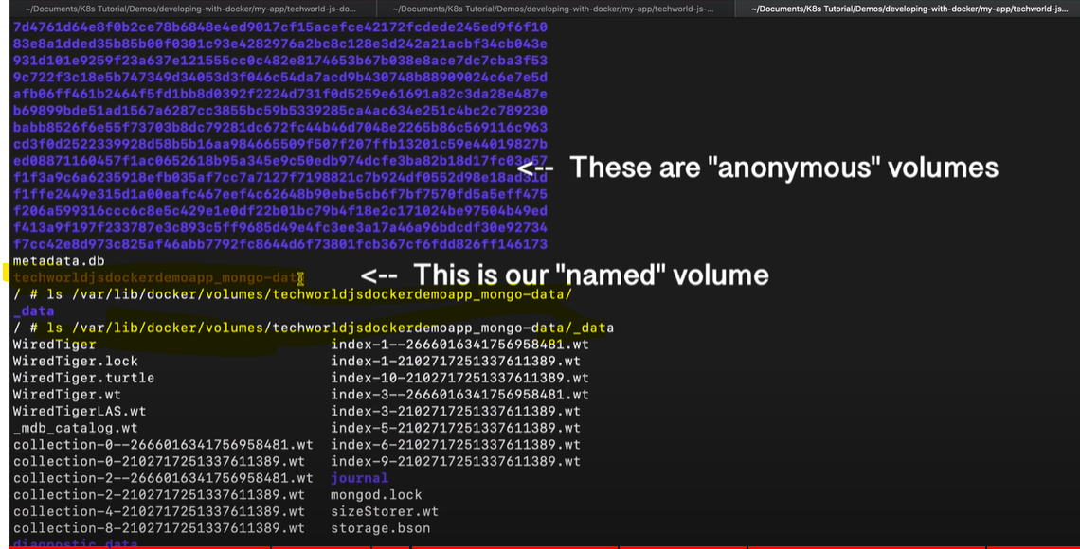



Next to learn container orchestration to distribute these containers

